Learner Modeling of Cognitive and Psychomotor Processes for Dismounted Battle Drills
Shitanshu Mishra1, Gautam Biswas1, Naveeduddin Mohammed1, Benjamin S. Goldberg2
1Vanderbilt University - Institute for Software Integrated Systems,
2U.S. Army Research Laboratory
INTRODUCTION
Operations such as “Enter and Clear a Room” and “React to Direct Fire Contact” are essential dismounted battle drills (DBD) for urban warfare conducted by the armed forces. These operations require the soldiers to develop effective psychomotor and cognitive skills, and cognitive strategies along with the ability to work in teams. This paper discusses our initial research in developing intelligent tutors that support team training for DBDs in virtual and augmented reality environments.
As a first step toward developing tutors, we conduct an initial study of the “Enter and Clear Room (ECR)” DBD that relies heavily on team member psychomotor skills and cognitive skills, such as identifying and differentiate enemy combatants from noncombatants in the room, and providing cover for the other team members (Department of the Army, 2011). In addition to tactical skills, a squad also needs to develop strategic reasoning and decision making skills that are derived from situation awareness and planning to assure superior firepower inside and outside the building, determining the method of access into the build- ing and rooms of interest, and for controlling the tempo of the operations (Holmquist & Goldberg, 2007). Since the operations are performed as a team, it is crucial that the trainees also acquire team skills in addition to the task skills (Sinatra et al., 2018). The need to combine individual psychomotor skills, cognitive and strategic processes, along with teamwork introduces a number of complexities in designing training sce- narios and evaluating individual and team performance and effectiveness in these scenarios. The need to evaluate psychomotor, cognitive, strategic, and affective processes implies the need for multiple monitoring modalities, such as computer logs of individual and team performance, video analysis for analyzing psy- chomotor and cognitive skills, eye tracking for monitoring situation awareness, and physiological sensors to capture affect. Multi-modal data capture becomes even more critical when monitoring and analyzing complex teamwork.
Figure 1 summarizes our overall approach to evaluating individual and team performance in synthetic train- ing environments (STEs). In particular, we propose a number of performance and effectiveness metrics, propose, and corresponding measures for the Squad Advanced Marksmanship Trainer (SAM-T) implemen- tation of ECR training operations for squads. We propose to compute these metrics within the Generalized Intelligent Framework for Tutoring (GIFT) framework (Sottilare et al., 2012), and develop integrated per- formance and effectiveness measures to support After Action Review by human instructors.
ENTER AND CLEAR ROOM (ECR) DOMAIN
"Enter and Clear Room" training scenarios are typically designed for a squad, i.e., a team of four soldiers. They represent a form of urban warfare, where enemy personnel have been located in a building that may also house noncombatants. The overall operations are initiated by securing the area around the building, and security forces are positioned in and around the building. A squad of four (sometimes two or three) are assigned to clear and secure a specific set of rooms, and the operation to clear each room begins on the order of the clearing team leader. It involves seizing control of the room by rapidly and tactically entering the room and neutralizing the enemy, while minimizing harm to the squad and the noncombatants. To

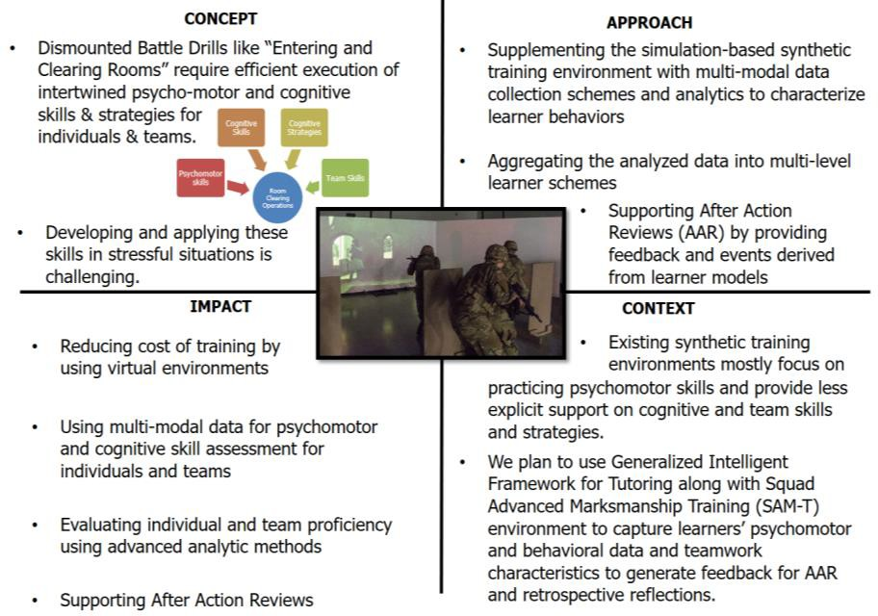

Figure 1. Quad chart showing the overall objective of the project
accomplish this, the army divides up ECR missions into five major task segments Sinatra (2018): (1) Pre- pare to Enter, (2) Enter the Room, (3) Clear the Room, (4) Secure the Room, and (5) Completion and move on to next assigned operation. In this paper we focus on the segment of "Clear the room". Accompanying these tasks are well-defined rules of engagement (ROE). In this paper, we focus on task segments (2) and (3), i.e., ECR, which involves entering a room quickly and stealthily, moving immediately to points of domination (POD) while eliminating enemy combatants with superior fire power, and once clear seize con- trol of the room. Figure 2 illustrates the tasks steps related to ECR. They are summarized below:
STEP 1. The squad in tight formation readies to enter the room, checks for booby traps on the door, and on a signal, usually a pat or an arm squeeze from the team lead (usually at the second position), is passed on to the first, starts the entry process (this may involve kicking down the door).
STEP 2. The first two Soldiers enter the room almost simultaneously. (Figure 2a). The first Soldier enters the room and moves left or right along the path of least resistance (typically the wall) to one of two corners. The soldier enters firing aimed bursts into his sectors engaging all threats or hostile targets to cover his entry. He assumes a POD facing into the room.
STEP 3. The second Soldier enters the room immediately after the first Soldier. He moves in the opposite direction of the first Soldier to his point of domination, also firing aimed bursts to engage and eliminate all threats in his sector.
STEP 4. The third Soldier moves in the opposite direction of the second Soldier while scanning and clear- ing his segment of the room. In some situations, the third soldier is assigned to cover threats from the top, i.e., the ceiling or gaps that may exist in the ceiling. (Figure 2b)
STEP 5. The fourth Soldier moves opposite of the third Soldier to a position that dominates his sector, also scanning and clearing his assigned region. (Figure 2c)
STEP 6. All Soldiers are positioned at their PODs as they continue to scan their sectors and engage enemy combatants with precision aimed fire, while avoiding injury to the noncombatants.
STEP 7. The team assesses if the room is neutralized. The team leader announces (or sends message) to the squad leader when the room is "CLEAR."
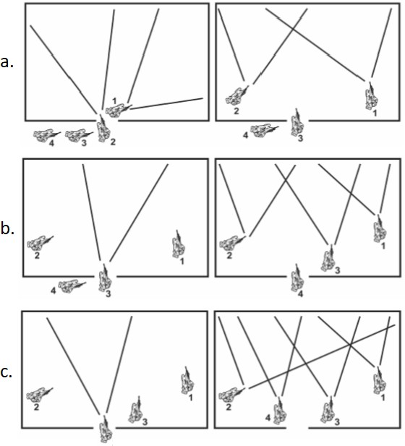
Figure 2. Clear a room: a) First two Soldiers enter almost simultaneously; b) Third soldiers enters; c) Fourth soldier enters
Expert interviews made us aware that a lot of rapid assessments and decisions need to be made by the soldiers from the start to the end of the clearing operation. In other words, proficiency in the clear operation requires superior muscle memory (Scales, 2013). For example, at the start of entering the room, the position of the door hinges may influence the direction of the movement of the first and the second soldier. If the door hinge is on the left (right) then the first soldier turns to the right (left) side. The second soldier goes in the direction opposite to the first. A second rapid decision a soldier needs to make is whether a person in the room is a combatant or not. A number of factors, e.g., possession of weapon and whether the person kneels when commanded, influence such decisions. We discuss psychomotor and cognitive skills and strat- egies for ECR operations in greater detail below.
ECR TRAINING ENVIRONMENT: SAM-T
The Squad Advanced Marksmanship Trainer (SAM-T) is a Training as a Service (TaaS) solution designed to enable army readiness and bridge the dismounted virtual collective training capability gap pending field- ing of the Soldier/Squad Virtual Trainer in 2021. SAM-T (Figure 3) is an augmentation (not a replacement) of Engagement Skills Trainer (EST) II, which was designed to simulate live weapon training events that directly support individual and crew-served weapons qualification, including individual marksmanship, small unit collective and judgmental escalation-of-force exercises in a controlled environment [https://asc.army.mil/web/portfolio-item/engagement-skills-trainer-est/]. SAM-T is intended to improve and accelerate Soldier and Squad close combat skills, and task acquisition by providing the realistic repeti- tions in diverse complex operational environments necessary to increase readiness.
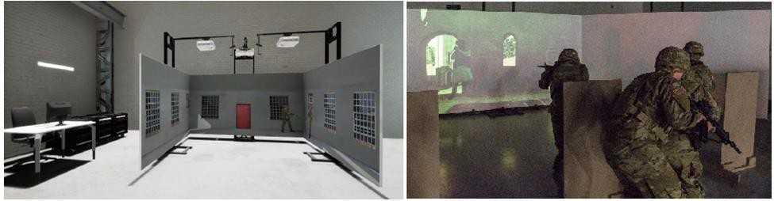

Figure 3. U-Shape System Configuration for SAM-T (Pargett, 2019)
The expected capability listing for SAM-T include: (i) Weapon Skill Development: An immersive individ- ual, crew, and collective weapon skill development training capability; (ii) Use of Force (UoF): Use of Soldier cognitive functions to include rapid decision making and target acquisition in stressful scenarios; (iii) Battle Drill Training: This dismounted maneuver requires the capability to conduct collective battle drills and tasks. Basic collective task training that SAM-T provides include: (i) Enter and clear a room; (ii) React to direct fire contact while dismounted; (iii) Employ hand grenades; and (iv) Use visual signaling techniques. The scope of our project is limited to ECR operations. Training in the SAM-T is customizable as per individual/team readiness and requirements. Variation and combination of stressors address multiple customizations and scenarios. Three variations are included: (1) change in physical layout (e.g., obstacle, training area, etc.); (2) change in physical parameters (e.g., target distances, target movement, and target appearance, etc.); and (3) Human factors (Callisthenic tasks, Cognitive tasks, Personal Equipment varia- tions, etc.)
Proposed Design and Analysis
We propose to integrate SAM-T with GIFT and action review modules (Figure 4). The user behavior logger attached to the SAM-T environment includes multiple sensors with different modalities. We anticipate to have data collected from Integrated visual augmentation system (IVAS), audio communication data, data from head-mounted eye trackers, data related to gun, for example: x-y-z coordinate locations of the gun from the screens, weapon trigger events, weapon states, bio harness sensors, and video observations. Train- ees, in teams of 3−5 would enter the virtual room (the SAM-T environment) to perform and practice ECR operations. The user behavior logger module will log the soldier movement data in video and motion track- ing form. The GIFT module will be designed to analyze the multimodal data and generate feedback for the After Action Review (AAR) module. Overall, GIFT module will primarily perform four functionalities: (i) Detection of task and team skills attributes from the data; (ii) Evaluation of individual and team perfor- mance and identification of deficient skills and strategies at individual and team levels; (iii) Learner mod- elling to aggregate and keep track of learner and team performances for various skills and strategies over multiple practice scenarios; (iv) Feedback generation for individual and for team based on reports generated from the learner model. The AAR module, with or without the presence of the human moderator (coach) will provide formative feedback and replays of the trainee’s behavior to help them to perform retrospective reflections and regulate their performance in subsequent practice iterations. The action review module can have two parts: (i) mid action reviews, where the feedback and reviews are given in between the practice session without any moderation of the external human agent (i.e., coach). Whereas, in the case of after action reviews, the action review module can be moderated by the human coach to help the trainees reflect on their performance.

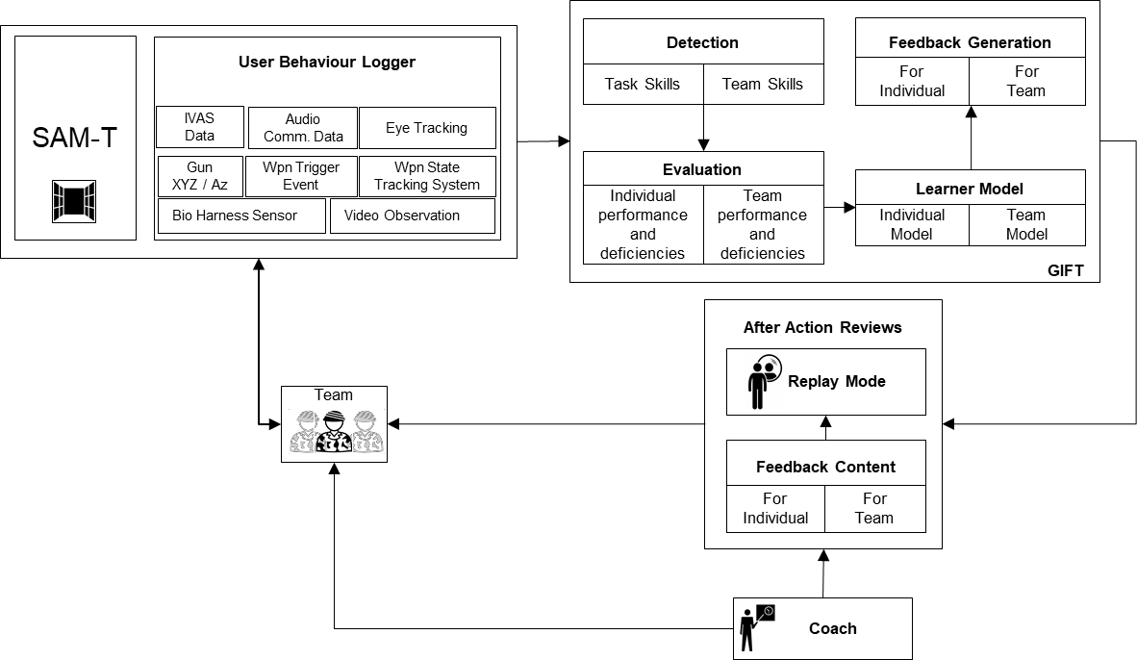

Figure 4. Proposed integration of SAM-T with GIFT and Action Review modules
Tracking Learner and Team Proficiencies: Method
Analyzing team tasks and defining individual task and team skills along with quantitative measures of per- formance and effectiveness (MOP and MOE) represent the initial steps towards developing team tutors. In addition to referring to army training manuals (especially the Army Training Registry and Central Army Registry (CAR)), we also conducted informal interviews with Subject Matter Experts (SMEs) to gain an overall understanding of the ECR processes and steps at the psychomotor, cognitive, and strategic levels. Our expert interviews started with a broad question: “What are the key characteristics and key steps in the ECR process? Once we had an overall understanding of the ECR process and steps (the important pre-, during-, and post-activities), we dove deeper into the psychomotor, tactical, strategic, cognitive and team skills that the soldiers needed to exhibit for successful ECR operations?” In addition, as the interviews progressed, we asked a lot of “what if” questions, mainly to gain an understanding of how standard operat- ing procedures (SOPs) might deviate, when unusual situations were encountered. Inductive thematic anal- ysis of the interview transcripts was performed to extract categories of psychomotor and cognitive skills and strategies (Guest, MacQueen, & Namey, 2011). This form of task analysis produced the list of psycho- motor skills and methods for measuring these skills as has been described in Tables 1 and 2.
Measures
The learning environment will compute a number of individual and team performance measures as trainees practice ECR scenarios. These performance measures, along with knowledge of trainees' actions in the environment have to be logged, such that they can further be used for analyzing learners' proficiencies related to the ECR domain. Table 1 shows a list of performance measures for proficiencies relevant to the "clearing room" segment of the ECR operation. The second and third column of the table provide prelimi- nary definitions of how these measures are computed and the sensing modality that provides the information for computing the measures, respectively. The list of measures shown in the table includes proficiencies that are required: (1) ‘just’ before entering the room through the door; (2) executing the clear operations in the room; and (3) securing and executing the room after the clear operations are completed. We have listed measures of performance and effectiveness that are primarily relevant to the “clearing” segment. We plan to refine and expand these measures through further consultations with our subject matter experts, collect- ing and analyzing video data of soldier movements during the move, and learning more about the variations to the standard clear scenarios and how the standard operating procedures are modified to adapt to these scenarios.

Table 1. Performance measures in ECR operation

Performance Measures |  | Measure Values | Data Source
M1 | Soldiers (Team of 4) line up at the door | M1 = 0, if trainee is not on the door location  = 1, if trainee is on the door location | Video Obser- vation
M2 | Keeping eyes in as- signed regions | M2 = [0,1], normalized angular deviation | Eye Tracker
M3 | Speed of Entry | M3 = 0, if time difference is > threshold 1, if time difference is < threshold | Video Observation
M4 | Concealed presence | M4 = 0, if needless talking or exposing the tip of a rifle across an open doorway  = 1, otherwise | Video Obser- vation
M5 | Signal to commence operation (Leader) | M5 = 0, failed to deliver signal  = 1, successful, used SOP for communication during entering (either Triceps squeeze, Shoulder squeeze, or Muzzle dip) | Video Obser- vation
M6 | Enter the room in the correct direction | M6 = 0, if direction is opposite to the direction of previous trainees  = 1, otherwise | Video Obser- vation
M7 | Moving along the wall | M10 = [0, 1], normalized count of number of conditions satisfied from below:  - Trainee continues moving while clearing  - Stops if reached corner or to a POD  - Continues moving along one wall after reaching corner  - Speed of movement is in the range where they can move while accurately engaging any targets  - Did not over-penetrate into the room | Video Obser- vation
M8 | Identifying adversaries | M7 = (M7gaze+ M7gun)/2  M7gaze = [0,1], normalized angular deviation between gaze azimuth and the position of the adversary,  M7gun = [0,1], normalized angular deviation between gun azimuth and the position of the adversary | Eye Tracker, Gun Azimuth
M9 | Eliminating nearest threat | M8 = [0, 1], normalized count of number of conditions satisfied from below:  - Threat is dealt before clearing the near corner  - Either a minimum of one round shot if adversary is armed or a well-placed arm check if unarmed  - Not stuck into firefight  - Not stuck into addressing a potential threat deep in the room | Video Obser- vation,  Gun Azimuth, Gun Trigger
M10 | Watching the near corner | M9 = [0, 1], how quick the trainee has scanned/ cleared the near cor- ner, 0: Fixated for too long, 1: Fixated for minimum required time | Eye Tracker

M11 | Collapsing a sector | M11  = 1, if scan overlaps teammates sector of fire by a threshold  = 0, if scan overlaps teammates sector of fire by more than a threshold  = 0, if scan doesn’t overlaps teammates sector of fire | Gun Azimuth, Eye Tracker
M12 | In-operation Commu- nication | M12 = [0, 1], normalized count of number of conditions satisfied from below:  - Communicated if any movement outside of the tactic  - Communicated danger areas if found  - Communicated any intent to move deeper into the room for a search | Audio Comm.  Data, Video Obser-  vation
M13 | Non-combatant casu- alty | M13 = -1, if gun triggered and gun azimuth aligns with the position of a civilian or non-combatant  = 0, otherwise | Gun Azimuth, Gun Trigger
M14 | Marksmanship | M14 = normalized marksmanship score with respect to the current tar- get | Marksmanship performance
M15 | Reporting exit | M15 = 1, if used SOP for communication during exiting (i.e. Sent “Clear” message)  = 0, otherwise | Audio Comm.  Data
... | ... | …. | ….

Table 2 shows how different performance measures can inform overall individual and team performances at each step of the “clearing room” segment of ECR operation. (These steps correspond to the seven steps during the room clearing task discussed at the beginning of this section.) To compute the overall perfor- mance of an individual trainee, performance values corresponding to that trainee across all the steps have to be aggregated. Whereas, to compute the team performance for any specific step, performance values corresponding to that step across all the trainees have to be aggregated. The overall team performance can be the aggregation of the team performances at individual steps.
Table 2. Aggregating individual and team performances

Trainee | Step1 (S1) | Step2 (S2) | Step3 (S3) | Step4 (S4) | Step5 (S5) | Step6 (S6) | Step7 (S7) | Overall
T1 | 𝑓(M1, M2, M3, M4) | 𝑓(M6, M7, M8, M9, M10, M13, M14) | 𝑓(M7, M8, M9, M10 M12, M13, M14) | 𝑓(M7, M8, M9, M10, M12, M13, M14) | 𝑓(M7, M8, M9, M10, M12, M13, M14) | 𝑓(M7, M8, M9, M10, M11, M12, M13, M14) | 𝑓(M15) | ℎ(S1:S7)
T2 | 𝑓(M1, M3, M4, M5) | 𝑓(M4) | 𝑓(M7, M8, M9, M10, M13, M14) | 𝑓(M7, M8, M9, M10, M12, M13, M14) | 𝑓(M7, M8, M9, M10, M12, M13, M14) | 𝑓(M7, M9, M10, M11, M12, M13, M14) | 𝑓(M15) | ℎ(S1:S7)
T3 | 𝑓(M1, M4) | 𝑓(M4) | 𝑓(M4) | 𝑓(M6, M7, M8, M13, M14) | 𝑓(M7, M8,, M9, M10, M12, M13, M14) | 𝑓(M7, M9, M10, M11, M12, M13, M14) | 𝑓(M15) | ℎ(S1:S7)
T4 | 𝑓(M1, M4) | 𝑓(M4) | 𝑓(M4) | 𝑓(M4) | 𝑓(M6, M7, M8, M12, M13, M14) | 𝑓(M7, M9, M10, M11, M12, M13, M14) | 𝑓(M15) | ℎ(S1:S7)
Team | 𝑔(T1:T4) | 𝑔(T1:T4) | 𝑔(T1:T4) | 𝑔(T1:T4) | 𝑔(T1:T4) | 𝑔(T1:T4) | 𝑔(T1:T4) | ℎ(S1:S7)

LEARNER MODELING
In past work, we have developed hierarchical learner modeling schemes that involve open-ended learning in K-12 environments (Rajendran et al., 2017, Kinnebrew et al., 2017) and problem solving involving com- plex decision making tasks (Biswas et al., 2019, in review). The learner modeling scheme is meant to ana- lyze and represent trainee's proficiencies in complex decision-making scenarios. In the current project, our overall goals are to extend this multi-level learner modeling approach to Battle Drill domains. One signifi- cant addition to this framework will be the addition of a psychomotor task modeling layer to the existing three-layer model that we have developed in previous work.
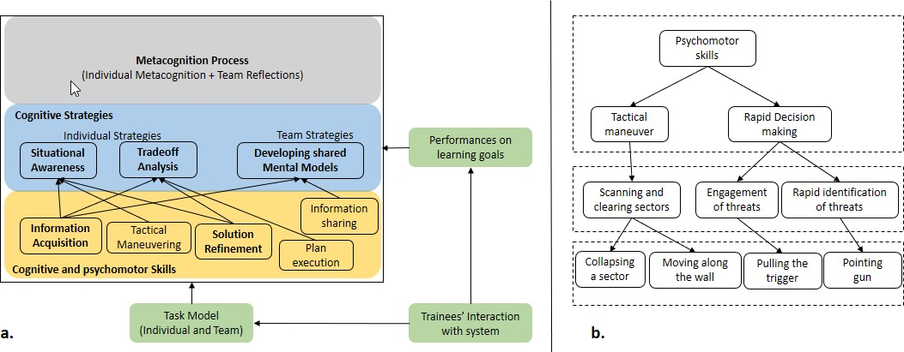
At each step, the learner model will use trainee's performance on specified goals (and sub-goals) and tasks (the measures were discussed in the last section) to update the different levels of the hierarchy (Figure 5a). The cognitive (and psychomotor) skills layer of our learner model will derive information of a trainee's interactions from behavior logs generated by the Behavior Logger module (Figure 4). These behavior logs will serve as an assessment of leaner's ability to execute domain-specific knowledge and skills. For exam- ple, during the clearing operation, the trainee has to tactically maneuver inside the room that requires him to move along the wall. The learning environment will keep track of whether the trainee moves well along the wall (M7 in Table 1) while he is inside the room or not. If the trainee does not conform to the standards of moving along the wall (M7) the learner-modeling framework attributes this to trainee's lack of 'tactical maneuvering' skill. The next layer, the cognitive strategies level, will involve conditional knowledge about how to combine situation-specific information and cognitive/ psychomotor skills to accomplish higher level tasks and goals (Kinnebrew et al., 2017). The conditional aspect of cognitive strategies involves under- standing when a strategy is most effective, especially when there are multiple potential courses of action available to the trainee. The top layer will use tracked changes in trainee's performance on specified goals and strategies, and observable interactions with the After Action Review module to capture the trainee's proficiency in metacognitive processes.
Figure 5. a) Three Tier Hierarchical Learner Model; b) A part of task model for psychomotor skills
Each practice sessions of ECR are very short (5 secs to 60 secs for inside-room operation). For such a complex and rapid decision-making task, trainees continually apply skills and strategies to make decisions and conduct operations within and across practice iterations. Hence, we accumulate trainees' proficiencies in skills and strategies as a function of time (practice iterations in SAM-T). We will use the performance metrics 'competence' and 'trend' (Biswas et al., 2019, in review) to measure the evolution of learners’ proficiencies in skills and strategies in SAM-T. Competence (Ct) captures the learner’s accumulated profi- ciency on a skill or strategy, while the trend value (T) for a specific skill or strategy represents a local measure of how the learners’ competence evolves with practice iterations. As defined by Biswas et al. (2019, in review) competence (Ct) at any time iteration t is defined as the sum of the learner’s competence in that skill (strategy) at iteration, t - 1, and the value representing an aggregation of performances on all observable actions relevant to any skills or strategy at the iteration t, i.e.,

Ct = Ct-1 + f(performance on observable actions)

The trend value (T) can be computed as a function of the change in competence over the last two iterations, defined as:
T = g((Ct – Ct-1); (Ct-1 – Ct-2)), where g can be defined by the system designer.

To compute proficiency in a strategy, we combine trainees' performance in a related sub-goal and related skill(s). When learner's competence in executing a skill and performance in achieving a related sub-goal, both are positive, that implies a positive application of the related strategy, and, therefore, we increment the proficiency in the strategy positively. Whereas, a non-positive performance in sub-goal indicates ineffi- ciency in the application of related strategy, irrespective of whether the competence in executing the related skills is positive or not. However, in a weird case, when sub-goal performance is positive but skill compe- tence is negative, the effectiveness of applying the strategy is hard to detect.
An essential precursor to authoring any team tutor is the analysis of team tasks and defining task skills and team skills and thereby creating a task model that contains a hierarchy of learning environment (LE) – general skills, LE-specific tasks and observable behaviors in LE. The tasks model informs the lowest layer (skills layer) of the learner model with the observable behaviors linked with the skills. Figure 5b presents an example of part of the task model and presents a subset of psychomotor skills, extracted during our initial task analysis. Figure 5b elaborates two skills (i) tactical maneuvering; and (ii) rapid decision making. Ac- cording to Figure 5b, tactical maneuvering requires collapsing a sector (M11) and moving along the walls (M7) in the room. Performance measures M11 and M7 in Table 1 can be used to measure trainee’s profi- ciency in tactical maneuvering. Similarly, Rapid decision making involves instantaneous decision making and responding by pointing the gun towards or shooting at inhabitants, once they are identified as enemy combatants. Similar to the part of the task model corresponding to the psychomotor skills, the task analysis also provided sets of relevant tasks that require cognitive skills and team skills for the phases before, during and after clearing room.
CONCLUSIONS
In this paper, we presented our initial work towards the creation of an intelligent learning environment that supports the training of army personnel on the skills and strategies necessary for successfully conducting the ECR operations. Preliminary takeaways from referred documents and subject matter experts have re- vealed that speed (time), accuracy, and marksmanship are key factors for a successful ECR operation. Trainees have to develop muscle memory, which can only be acquired through iterations of practice. Skills involving rapid decision making, for example, identification of combatants and non-combatants requires iterations of practice with variations in the room inhabitants across multiple practice iterations. In addition to the individual task skills, team skills are also needed to ensure that the trainees efficiently follow stand- ards of procedures, adhere to the rules of engagements, communicate, and avoid disastrous fratricide.
It should be noted that the exact protocols of entering and clearing the room may not be replicated all the times. For example, the first soldier may not move along the wall if there is furniture in his path, and, therefore, he may have to improvise the path. Similarly, based on the room configurations (objects and inhabitants in the room) the soldier may have to choose different domination points, other than room cor- ners. Therefore, default trajectories and the rules of engagement discussed in this paper do not apply uni- versally, but have to be modified to accommodate characteristics of the actual scenario. This makes ana- lyzing user performance and effectiveness in the ECR domain more challenging. The need to evaluate both individual and team skills and performance adds to the challenge. As we proceed, more expert interviews, literature synthesis and observations of trainees performing the ECR operations are needed to enrich the task model and the computation of measures of performance and effectiveness (MOP and MOE) to update the task model. Capturing multimodal learner data as described in this paper, would provide the framework for accurately measuring learners' performances in such complex scenarios that require keeping track of psychomotor, cognitive and team skills, and infer their cognitive strategies. We also look forward to further enhance the team assessment by incorporating the Squad Performance Model to measure the team Lethality.
REFERENCES
Biswas, G., Rajendran, R., Mohammed, N., Goldberg, B.S., Sottilare, R.A., Brawner, K., and Hoffman, M. (2019, in review). “Multilevel Learner Modeling in Training Environments for Complex Decision Making,” IEEE Transactions on Learning Technologies.
Guest, G., MacQueen, K. M., & Namey, E. E. (2011). Applied thematic analysis. Sage Publications.
Fletcher, J. D., & Sottilare, R. A. (2018). Shared mental models in support of adaptive instruction for teams using the GIFT tutoring architecture. International Journal of Artificial Intelligence in Education, 1-21.
Holmquist, J. P., & Goldberg, S. L. (2007). Dynamic Situations: The Soldier's Situation Awareness. University of Central Florida Orlando.
Kinnebrew, J. S., Segedy, J. R., & Biswas, G. (2017). Integrating model-driven and data-driven techniques for ana- lyzing learning behaviors in open-ended learning environments. IEEE Transactions on Learning Technolo- gies, 10(2), 140-153.
Pargett, M. (2019, March 25). Squad tactics tested on new virtual marksmanship trainer. Retrieved April 2, 2019, from https://www.army.mil/article/219231/squad_tactics_tested_on_new_virtual_marksmanship_trainer
Rajendran, R., Mohammed, N., Biswas, G., Goldberg, B. S., & Sottilare, R. A. (2017). Multi-level User Modeling in GIFT to Support Complex Learning Tasks. In Proceedings of the 5th Annual Generalized Intelligent Frame- work for Tutoring (GIFT) Users Symposium (GIFTSym5).
Randel, J. M., Pugh, H. L., & Reed, S. K. (1996). Differences in expert and novice situation awareness in naturalistic decision making. International Journal of Human-Computer Studies, 45(5), 579-597.
Scales, B. (2013). Virtual immersion training: bloodless battles for small-unit readiness. The Magazine of the Asso- ciation of the United States Army, 24-27.
Schraw, G., Crippen, K. J., & Hartley, K. (2006). Promoting self-regulation in science education: Metacognition as part of a broader perspective on learning. Research in science education, 36(1-2), 111-139.
Sinatra, A. M., Kim, J. W.,2, Johnston, J., Sottilare, R. A. (2018). Assessment of Team Performance in Psychomotor Domains. Design Recommendations for Intelligent Tutoring Systems: Volume 6. US Army Research Labor- atory.
Sottilare, R. A., Brawner, K. W., Goldberg, B. S., & Holden, H. K. (2012). The generalized intelligent framework for tutoring (GIFT). https://gifttutoring.org/projects/gift/wiki/Overview
U.S. Department of the Army. (2011, June 10). Army Tactics, Techniques and Procedures – ATTP 3-06.11.
ABOUT THE AUTHORS
Dr. Shitanshu Mishra is a Postdoctoral Researcher at the Institute of Software Integrated Systems at Vanderbilt University.

Dr. Gautam Biswas is a Professor of Computer Science, Computer Engineering, and Engineering Management in the EECS Department and a Senior Research Scientist at the Institute for Software Integrated Systems (ISIS) at Vanderbilt University.

Naveeduddin Mohammed is a Research Engineer at the Institute of Software Integrated Systems at Vanderbilt Uni- versity.

Dr. Benjamin Goldberg is an adaptive training scientist at the Army Research Laboratory’s SFC Paul Ray Smith Simulation & Training Technology Center. He leads research focused on instructional management within ARL’s Learning in Intelligent Tutoring Environments (LITE) Lab and is a co-creator of the Generalized Intelligent Framework for Tutoring (GIFT).

