Architecture and Ontology in the Generalized Intelligent Framework for Tutoring: 2019 Update
Keith Brawner¹, Michael Hoffman², Benjamin Nye³, Chris Meyer⁴
U.S. Army Research Laboratory¹, Dignitas Technologies², Institute for Creative Technologies University of Southern California³, Synaptic Sparks Incorporated⁴
INTRODUCTION
The first version of the Generalized Intelligent Framework for Tutoring (GIFT) was released to the public in May of 2012. One year later, the first symposium of the GIFT user community was held at the Artificial Intelligence and Education conference in Memphis, Tennessee. Since then, the GIFT development team has continued to gather feedback from the community regarding recommendations on how the GIFT project can continue to meet the needs of the user community and beyond. This current paper continues the con- versation with the GIFT user community in regards to the architectural “behind the scenes” work and how the GIFT project is addressing the user requirements suggested in the previous GIFTSym6 proceedings. The development team takes comments within the symposium seriously, and this paper serves to address requirements from prior years.
As a follow up to the “GIFT 2015 Report Card and State of the Project” (Brawner & Ososky, 2015), the GIFT 2016 Community Report (Ososky & Brawner, 2016), the GIFT 2017 Architecture Report (Brawner, Heylmun, & Hoffman, 2017), and the 2018 paper (Brawner & Hoffman, 2018) the feature requests and responses have been broken out among a number of papers, and into logical sections of this work. This paper discusses the ongoing architectural workings and changes in support of the various sets of projects. The number of projects which the GIFT overall projects is now around 30, which continues to represent a) the inability for significant direct support of any individual project and b) the relatively little support that individual projects need to be successful. GIFT generally works well enough to support research studies without direct developer guidance or specifically developed features.
The remainder of this paper discusses the requirements requested from the last GIFTSym, the developed functionality new to this year and the continuation of community dialogue in paper form.
WELCOME
First, to the new members of the GIFT community and new GIFT users – Welcome! There are a number of recommended resources that will help to orient you to this project and ecosystem. GIFT has come a long way since its original goals were defined in its description paper (Sottilare, Brawner, Goldberg, & Holden, 2012). First, we would encourage you to simply get started, as the tools and example courses have been designed to try to be as easy as possible for the creation of intelligent tutoring systems.
If you struggle with any individual aspect of the system, however, the team has produced short “how to” videos to try to help around the sticking points. There are now many such videos available on the GIFT
YouTube channel, which is the first result if you search “Generalized Intelligent Framework for Tutoring Youtube” on Google. The YouTube videos have not been updated for the new release, however, the vast majority of the GIFT challenges and authoring has remained unchanged.
In addition to a Quick Start Guide, usable tools, and videos, there is support for developers in the help forums and documentation. The GIFT user community is also invited to ask questions and share your experiences and feedback on our forums (https://gifttutoring.org/projects/gift/boards). The forums are ac- tively monitored by a small team of developers, in addition to a series of Government project managers. The forums are a reliable way to interact with the development team and other members of the GIFT com- munity. The forums, at the time of this writing, have over 1200 postings and responses. Documentation has been made freely available online at https://gifttutoring.org/projects/gift/wiki/Documentation, with in- terface control documentation https://gifttutoring.org/projects/gift/wiki/Interface_Control_Document_2018-1, and a developer guide https://gifttutoring.org/projects/gift/wiki/Developer_Guide_2018-1. These documents are updated each software release.
GIFT CLOUD GENERAL REPORTING
GIFT Cloud is now legacy, and has been running more-or-less continuously for the last three years, in support of numerous experiments. At the time of writing, it appears that only developers download the downloadable versions of GIFT. Cloud GIFT is kept online and updated in advance of the downloadable version, meaning that content must be backwards-ported to be compatible with the perpetually out of date offline version. We do our best to keep the downloadable version to regularly scheduled improvements, but, for ordinary users, we would encourage you to use the Cloud version – it is better supported and more stable than the downloadable version. It supports hundreds of simultaneous users for experiments. Further, there are approximately 8 cloned cloud versions with different software configurations live at any given time. We are generally confident in the systems’ ability to stay up and cope with demand.
Behind the scenes, however, the re-tooling to move to a deployment version of dev-desk to dev-cloud to production has been working well. The team has greater ability to bug requests, with faster turnaround time. In this paper we reiterate that a clone of cloud.gifttutoring.org is always available upon request, and we have granted several requests over the year – necessitating an updating of the instructions to deploy a new cloud build and the hardening of those instructions. The previous version of this paper (Brawner & Hoffman, 2018) identified a number of organizations which had requested special access, but this number is now too great to count individually.
Virtual Machines Available Upon Request
As part of the move to Cloud GIFT, we have a number of specialized processes which run in the back- ground. Figure 1 shows the current structure of the Virtual Machine (VM) instances which operate Cloud GIFT. At its basic level, GIFT runs on two VMs; a Windows VM for all of the core GIFT features, and a Linux VM hooked up to an Amazon Relational Database Service (RDS) for the content. These items are what are contained in the downloadable GIFT instance. In addition to the basic instances, however, are services for monitoring GIFT; PiWik monitors user behaviors within the system, while the GIFT monitor- ing service monitors usage for future performance improvements. GIFT now includes an instance to a Social Media Framework (SMF) and Learner Record Store (LRS), which are based around Elgg and Learn- ing Locker, respectively. GIFT’s copies of these configurable items are available upon request, and posted to github, but the authors would urge users to select their own instances of commercial sharing and data warehousing items dependent upon their own individual needs; there is nothing tying GIFT to a specific SMF, LRS, PiWik, or monitoring framework. We do not think of these items as core to GIFT, only that they are reported outwards.

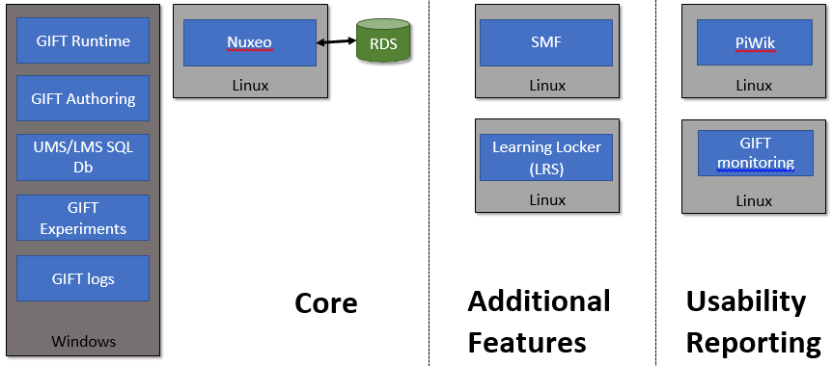
Figure 1: Simplistic Diagram of Cloud Gift Items
NEW INSTRUCTIONAL MODELS
A new Adaptive courseflow course object version was introduced in the interim release of GIFT, GIFT 2017-12-22. In this full release all legacy Adaptive courseflow course objects are now automatically con- verted to this new instance. Authors will now see a new icon for these course objects as well as an expanded Adaptive courseflow course object editor in the course creator. Learners taking a course with a legacy adaptive courseflow will mainly see a difference when it comes to remediation. In the past if you were deemed a novice on a course concept after a check on learning phase of an adaptive courseflow course object you would see both rule and example content as part of remediation. Now you will see a single piece of content for remediation of that concept. This is a part of upgrading to the reinforcement learning frame- work based upon the idea of Interactive-Constructive-Active-Passive methods of instruction (Rowe et al., 2018).
VIRTUAL HUMAN TOOLKIT (VHTK)
GIFT now supports 2 character servers, Media Semantics and Virtual Human. Both are available on the Downloads tab of gifttutoring.org. GIFT is now configured to use Virtual Human as the default character server, however you can still use custom Media Semantics characters in courses with no GIFT configuration changes by including the custom character in your course folder and then referencing that custom character appropriately (see Excavator and Explicit Feedback courses as examples). Note that if you need to run a character in IE 11 (or earlier) than you will need to use Media Semantics because Virtual Human uses the Unity WebGL player, which is not supported in older IE browsers. The development in this category was previously reported in a prior paper (Nye, Auerbach, Mehta, & Hartholt, 2017), but it is currently tested, released, and live. An additional two characters have been added to a development branch and are expected in future releases, assuming successful testing and validation.
LEARNING TOOLS INTEROPERABILITY (LTI)
Previous developments to the LTI interface was reported last year (CITE). This year involved minor tweaks of the interface, bilateral course sharing, and two course sharing publishing items. The LTI v2.0 interface was not particu- larly embraced by the community of developers at EdX, and thus the GIFT developers are following the lead of the larger Massive Online Open Courseware providers (Aleven et al., 2017) in moving to the updated v1.1.1.
LEARNER RECORD STORES AND COMPETENCIES
The authors wish to make the community aware that we are in the midst of integrating the Competency And Skills System (CASS) developed by the Advanced Distributed Learning (ADL) Initiative. The military and Army commu- nity have need of the technology represented by this community. Further, the xAPI community is embracing the technology through the implementation of xAPI Profiles (Bowe & Silvers, 2018) within the IEEE Learning Tech- nology Standards Committee (LTSC) (Robson & Barr, 2018) . In brief, the xAPI from GIFT courses informs com- petency assessments informs readiness assessments informs course recommendation which generates xAPI data in a virtuous cycle. We welcome participation, and more information on the exact developments can be found at:
- CASS - https://www.cassproject.org/
- xAPI Profiles - http://sites.ieee.org/sagroups-9274-1-1/
- LTSC - http://sites.ieee.org/sagroups-ltsc/home/
AUTHORING
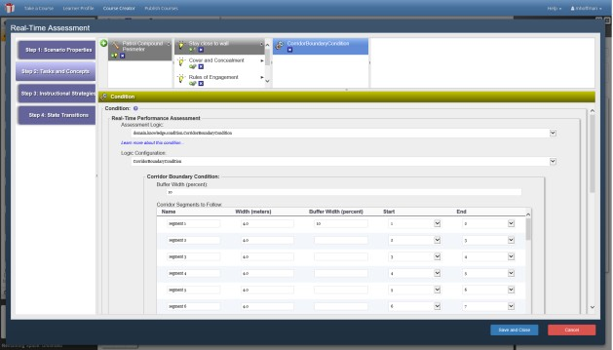
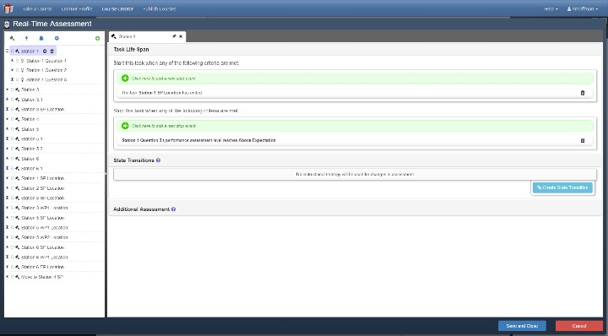
Massive improvements in authoring have been made since the last release, through the integration of pre- vious versions of “GIFT Wrap” as well as the larger number of deployed courses recently. The process for authoring assessments of this kind needed to be streamlined, and has. This is especially true in regards to the authoring of a “Domain Knowledge File” (DKF) or “Real Time Assessment”, which is what it is called on Cloud GIFT. The improvements here can be captured in the below screenshot, showing the old and new interfaces side to side. The improvements are substantial and noticeable.
Figure 2: Authoring Tools changes for GIFT Wrap
RESEARCH DIRECTIONS: TEAM AND PSYCHOMOTOR TRAINING
Part of the goal of the GIFT project is to expand tutoring systems from relatively well-defined domains to ill-defined domains, from desktop training to “in the wild” training, and from individual training to team training. This is part of the military interest in intelligent tutoring technologies – Warfighters train as a group, and within the training environment. This section provides an update to last years’ status on team training and psychomotor training.
Team Training
While specific research implementations can be read elsewhere within prior proceedings (Sinatra, 2018), the team has done specific work in order to show relevance to team training items. This technology was further developed into a demonstration at ITSEC and is now available for multiple projects upon request. This technology is scheduled for early implementation in the coming release, considering the priority that the Synthetic Training Environment (STE) is placing on team training, a “train as you fight” model, and on “25 bloodless battles” (Defense News, 2018) .
Psychomotor Training
Psychomotor, or “in the wild” training is a significant part of the reason for military investments in the intelligent tutoring technologies. The prototype land navigation mobile application reported upon last year (CITE) has now been released as software functionality, with the gains made in the authoring tools placed into the current release. The developments in land navigation have significantly shaped the outcomes of the authoring tools for new functionality.
OTHER COMMUNITY-REQUESTED FEATURES
Wheelspinning Prediction
A request for a prediction of wheelspinning behavior was included in last years’ proceedings (Park & Matsuda, 2018). The authors would hope that this implementation would be as simple as a sensor module plugin, taking the student answers as the input, doing processing in an interface of the author’s choice (RapidMiner, Python, XML-RPC, etc.), and exporting a new student state on the concept level; e.g. “Con- cept 1”:”Wheelspinning”. At that point, the student state could be given an instructional remediation using the standard body of GIFT authoring tools from a Domain Knowledge File (RealTime Assessment). This type of implementation should be relatively straightforward, and is covered in the “how to add a sensor” portion of the online documentation, at: https://gifttutoring.org/projects/gift/wiki/Developer_Guide_2019- 1#Integrate-a-Sensor.
Validated Motivational Assessments
Motivational assessment, as requested by the UCF group in last year’s GIFTSym is anticipated to transition into public use inside of the next 3 months (Biddle, Lameier, Reinerman-Jones, Matthews, & Boyce, 2018).
Natural Language Processing for Team Interactions
Efforts to begin researching natural language processing for the determination of team dynamics have be- gun, but have not yet made it into production. The authors welcome solutions and ideas which target lan- guage as a manner of team assessment, as they have been specifically requested by the community of GIFT users (Johnston, 2018).
Human In-The-Loop Functionality
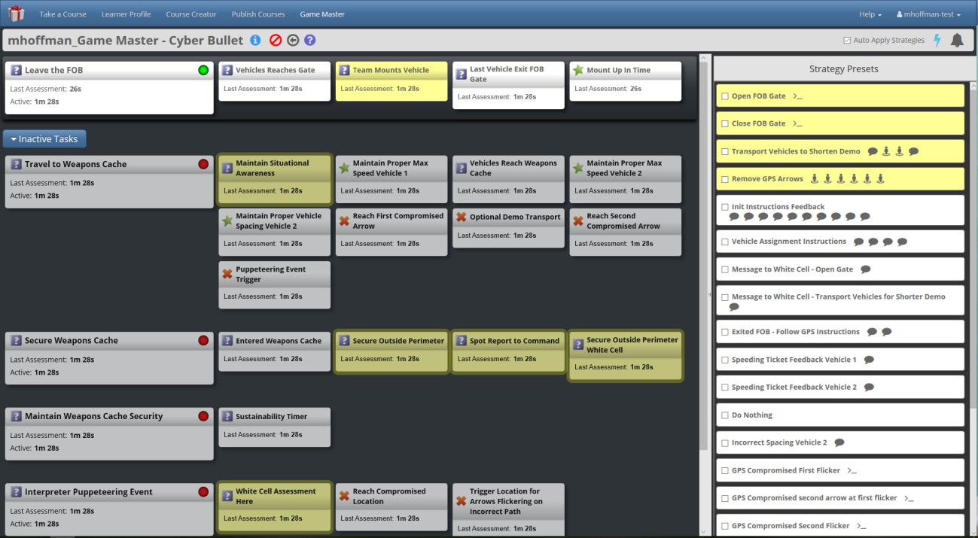
Recent projects, especially in the realm of larger teams, have demonstrated the need for a human-in-the- loop capability (McCormack, Kilcullen, Sinatra, Brown, & Beaubien, 2018). The idea behind this capabil- ity is that there will be an “auto mode” and a “manual mode” which function similar to a traditional intel- ligent tutoring system, and a ITS-as-you-approve-it feature set. Further, the human will be able to introduce manual assessments of any type that GIFT was initially programmed for. This functionality, as shown below, is currently available upon request, and is in testing internally on larger-scaled operations.
Figure 3: Enhanced Human-in-the-loop interface
Better User Guide
A better user guide was requested at last years’ GIFTSym (Julian, 2018). The authors hope that the updated manuals, new material, and YouTube video series would be helpful.
Predictive Analysis of Performance and Training ROI computations
This request has gone unaddressed and we welcome others in the community to take it up.
GIFT AND IEEE STANDARDS
As part of last year’s GIFT Symposium, there is an associated standards meeting. This standards meeting will be among those which occurred over the course of the year, including telephone calls, in-person meet- ings, proceedings presentations, and other activities. The IEEE Learning Technologies Standards Commit- tee, with support from the GIFT community and the Government, is now seeking involvement in standard- ization activities. The GIFT community invites the reader to join the conversation on what data exchange standards for learning technologies might look like in the future – there is now active IEEE community on the subject, to which the GIFT project is contributing meaningfully. Interested readers are encouraged to go to the IEEE LTSC meetings to become involved.
REFERENCES
Aleven, V., Baker, R., Blomberg, N., Andres, J. M., Sewall, J., Wang, Y., & Popescu, O. (2017). Integrating MOOCs and Intelligent Tutoring Systems: edX, GIFT, and CTAT. Paper presented at the Proceedings of the 5th Annual Generalized Intelligent Framework for Tutoring Users Symposium, Orlando, FL, USA.
Biddle, E., Lameier, E., Reinerman-Jones, L., Matthews, G., & Boyce, M. (2018). Personality: A key to Motivating our Learners. Paper presented at the 6th Annual GIFT Users Symposium.
Bowe, M., & Silvers, A. E. (2018). US DoD xAPI Profile Server Recommendations.
Brawner, K., Heylmun, Z., & Hoffman, M. (2017). The GIFT 2017 Architecture Report. Paper presented at the Proceedings of the 5th Annual Generalized Intelligent Framework for Tutoring (GIFT) Users Symposium (GIFTSym5).
Brawner, K., & Hoffman, M. (2018). Architecture and Ontology in the Generalized Intelligent Framework for Tutoring: 2018 Update. Paper presented at the Proceedings of the 6th Annual Generalized Intelligent Framework for Tutoring (GIFT) Users Symposium (GIFTSym6).
Brawner, K., & Ososky, S. (2015). The GIFT 2015 Report Card and the State of the Project. Paper presented at the Generalized Intelligent Framework for Tutoring (GIFT) Users Symposium (GIFTSym3), Orlando, FL.
Defense News, M. G. (Producer). (2018). 25 bloodless battles: Synthetic training will help prepare for current and future operations. Retrieved from https://www.defensenews.com/smr/defense-news- conference/2018/09/05/25-bloodless-battles-synthetic-training-will-help-prepare-for-current-and-future- operations/
Johnston, J. H. (2018). Team Performance and Assessment in GIFT–Research recommendations based on Lessons Learned from the Squad Overmatch Research Program. Paper presented at the Proceedings of the Sixth Annual GIFT Users Symposium.
Julian, D. (2018). Final Report for IDS6938 – Intelligent Tutoring System Design: Basic Robotic Course. Paper presented at the Proceedings of the Sixth Annual GIFT Users Symposium.
McCormack, R. K., Kilcullen, T., Sinatra, A. M., Brown, T., & Beaubien, J. M. (2018). Scenarios for training teamwork skills in virtual environments with GIFT. Paper presented at the Proceedings of the Sixth Annual GIFT Users Symposium.
Ososky, S., & Brawner, K. (2016). The GIFT 2016 community report. Paper presented at the Proceedings of the 4th Annual GIFT Users Symposium.
Park, S., & Matsuda, N. (2018). Predicting Students’ Unproductive Failure on Intelligent Tutors in Adaptive Online Courseware. Paper presented at the Proceedings of the Sixth Annual GIFT Users Symposium.
Robson, R., & Barr, A. (2018). Learning Technology Standards-the New Awakening. Paper presented at the Proceedings of the Sixth Annual GIFT Users Symposium.
Rowe, J., Spain, R., Pokorny, B., Mott, B., Goldberg, B., & Lester, J. (2018). Design and Development of an Adaptive Hypermedia-Based Course for Counterinsurgency Training in GIFT: Opportunities and Lessons Learned. Paper presented at the proceedings of 6th Annual GIFT Users Symposium.
Sinatra, A. (2018). Team Models in the Generalized Intelligent Framework for Tutoring: 2018 Update. Paper presented at the Generalized Intelligent Framework for Tutoring (GIFT) Users Symposium (GIFTSym6), Orlando, FL.
Sottilare, R., Brawner, K. W., Goldberg, B. S., & Holden, H. A. (2012). The Generalized Intelligent Framework for Tutoring (GIFT).
ABOUT THE AUTHORS
Keith Brawner, PhD is a senior researcher for the U. S. Army Combat Capability Development Command Soldier Center at the Simulation and Training Technology Center (CCDC-SC-STTC), and is a co-creator of the Generalized Intelligent Framework for Tutoring (GIFT). He has 13 years of experience within U.S. Army and Navy acquisition, development, and research agencies. He holds a Masters and PhD degree in Computer Engineering with a focus on

Intelligent Systems and Machine Learning from the University of Central Florida. His current efforts are on artificial intelligence for the Synthetic Training Environment Simulation and Network Compression. He manages research in adaptive training, semi/fully automated user tools for adaptive training content, and architectural programs towards next-generation training.

Michael Hoffman is a senior software engineer at Dignitas Technologies and the technical lead for the GIFT project. He has been responsible for ensuring that the development of GIFT, meeting community requirements, and supporting production ITS systems, ITS research, and the growing user community. Michael manages and contributes support for the GIFT community through various mediums including the GIFT portal (www.GIFTTutoring.org), annual GIFT Symposium conferences and technical exchanges with ARL and their contractors. In addition he utilizes his expertise in integrating third party capabilities such as software and hardware systems to enable other organizations to inte- grate GIFT into their training solutions.

