Extending GIFT Wrap to Live Training

Fleet C. Davis¹, Jennifer M. Riley², and Benjamin S. Goldberg³
BMT Inc.¹, Design Interactive Inc.², CCDC-Soldier Center, STTC³
Introduction
The Generalized Intelligent Framework for Tutoring (GIFT) is a modular suite of capabilities aimed at overcoming the challenges associated with authoring and delivering computer-based instruction via an intelligent tutoring system (Sottilare, Brawner, Goldberg, & Holden, 2012). One of the primary objectives for GIFT development is to create an integrated, user-friendly authoring experience that is training platform agnostic. Humanproof, with teammate Design Interactive, recently completed the fourth generation GIFT Wrap prototype, a software application that allows training developers to configure the real-time, automated delivery of instructional content triggered by assessing state changes within the training application’s learning environment and/or learner. The following sections summarize previous GIFT Wrap development efforts including the first three generations that focused on developing authoring tools across virtual- and game-based training environments, provide an overview of the fourth generation of GIFT Wrap for extending the functionality to live training environments, and discuss future applications of GIFT Wrap.
Background
Evolution of GIFT Wrap Development
The GIFT Wrap project was a multi-year, research and development effort aimed at developing a fully-integrated, user-friendly tool for authoring individual, adaptive training following a Crawl-Walk-Run (CWR) approach to training (Goldberg, Davis, Riley, & Boyce, 2017) that would employ multiple training applications. For the purposes of scoping this project, Army Map Reading and Land Navigation training (Department of the Army [DA], 2007) was selected as the primary use case.
The first and second generation of GIFT Wrap laid the foundation for the iterative development of the tool. These first two generations were aimed at overcoming the challenges associated with authoring a Domain Knowledge File (DKF) (Shute, Ventura, Small & Goldberg, 2013) and the disconnect between GIFT authoring tools and training application content creation tools (Davis, Riley, & Goldberg, 2017). The resulting proof-of-concept provided a “blended authoring environment” that allowed users to author real-time assessments directly within the context of a training application’s virtual environment (i.e., the Augmented Reality Sandtable (ARES) terrain map) (Hoffman, Markuck, & Goldberg, 2016) and a completely redesigned user interface (UI) for authoring a Domain Knowledge Files (DKF) (Davis et al., 2017) (see Figure 1). At this stage, GIFT Wrap supported the Crawl phase of skill acquisition focused on the fundamentals of Map Reading and Land Navigation.
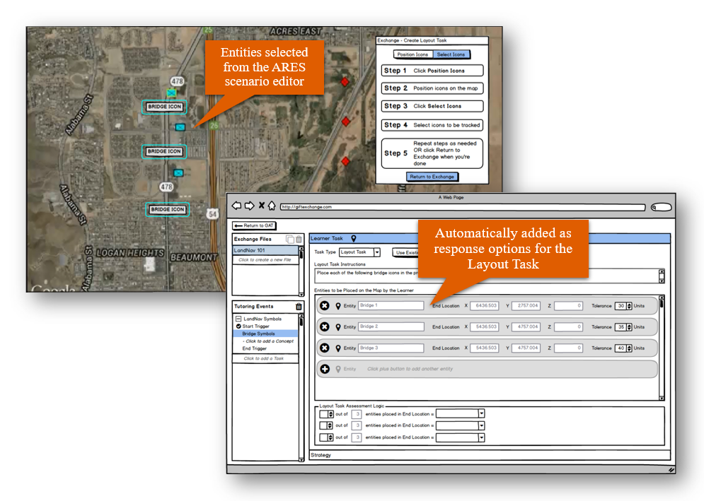
Figure 1. Authoring in ARES – 2nd Generation GIFT Wrap
The third generation of GIFT Wrap incorporated additional features for authoring DKFs and extended the blended authoring experience to include the LandNavHD Unity game, a computer-based land navigation trainer used as a practice environment for dead reckoning procedures (Davis, Riley, & Goldberg, 2018) (see Figure 2). The third generation of GIFT Wrap supported the Walk phase of skill acquisition focused on applying Map Reading and Land Navigation knowledge within an interactive exercise.
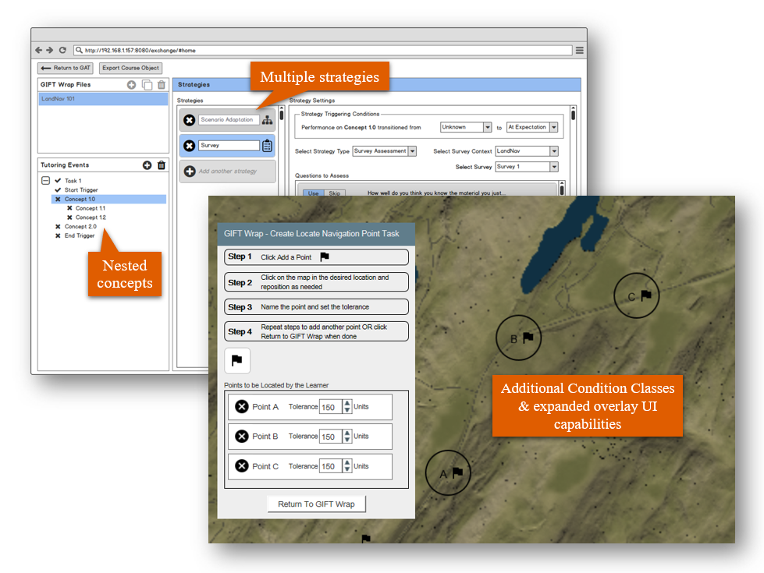
Figure 2. Authoring in LandNavHD – 3rd Generation GIFT Wrap
GIFT Wrap within the Course Development Process
GIFT course development is primarily supported through the GIFT Course Creator. With this interface, the author sets the course properties, defines the course objects, and applies relevant media to the instructional elements and approaches. The Course Creator provides interface components to set variable parameters for the provided course objects. GIFT Wrap provides additional interfaces to set parameters that are specific to the implementation of real-time assessments that occur during the completion of the overall course.
A few elements should be accounted for in the application of real-time assessments that relate directly to utilization of GIFT Wrap in the scenario development process. The author should have defined the course “concepts” to be addressed and the course objects that will have real-time assessments associated with them. Based on the defined concepts and corresponding assessments, the relevant training application(s) should be selected. Two approaches are presented here as examples on GIFT Wrap applications.
First, the author can include a course object referencing the direct application of a training applications (e.g., Virtual Battlespace (VBS), ARES, PowerPoint) for presenting a real-time assessment to the learner. In the same manner, the author adds the relevant course object for a training application within the course flow. The course object presents selections, for example, to identify specific scenarios to be used within the training application and the real-time assessment to be applied. GIFT Wrap would be invoked for setting up the relevant parameters of the real-time assessment – the concept to be assessed, the manner of assessment, the criterion for triggering the assessment, the criterion for assessing performance, and the strategy to be applied given the performance outcomes. The user can set up the parameters prior to using GIFT, or with the direct integration of GIFT Wrap with the GIFT software, the author can access GIFT Wrap when setting up the real-time assessment with the training application course objects.
A second application for using GIFT Wrap is the application of an “adaptive course flow” object. This is a course object that facilitates adaptive behaviors within the course, including providing remedial instructional content for concepts for which the learners fail to reach a pre-set performance criterion. As with the real-time assessment, the course concepts must be defined. With this course object, the author can elect to push the learner through a “practice phase”. This practice phase is essentially a strategy that is presented if performance on the “check on learning” element of the adaptive course flow does not reach desired levels. The “practice phase” initiates practice within a training application. As with the real-time assessment setup, when the training application is applied, the author would utilized GIFT Wrap to define the practice, which is essentially the tasks to be completed to rehearse and assess the skill associated with the concept, as well as to define the criterion for whether or not the desired performance is achieved with the practice. If the performance is acceptable, per the parameters set by the author, the learner is allowed to move ahead in the course. If the performance is not acceptable, the learner remains within the flow or loop of the adaptive course flow object.
In either case of the course setup, GIFT Wrap is used when the author is setting up parameters associated with activities in a selected training application. If the author has pre-defined the concepts, the tasks of interest, and the other elements of interest to a practice phase or real-time assessment (e.g., areas of interest, points or locations of interest, entities of interest), GIFT Wrap can be used to define those before the development of the GIFT course. If the author has not pre-defined each element of the course, they can use GIFT Wrap as the course is being set up, moving between the GIFT Wrap and the Course Creator as needed to set up parameters for real-time assessments and adaptive course flow practice opportunities.
Fourth Generation GIFT Wrap
Extending the Blended Authoring Experience to Support Live Training Exercises
The GIFT Wrap blended authoring experience was extended beyond the ARES and LandNavHD training applications to live training exercises authored within Google Maps. Using the Google Web Toolkit (GWT), the GIFT Wrap Overlay UI was integrated with Google Maps allowing users to author real-time assessments on any area of the map (see Figure 3).
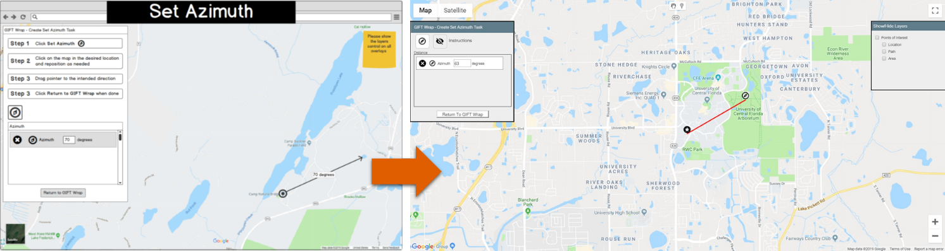
Figure 3. Example of Overlay UI Design Translated to Functional Implementation
In addition to GIFT Wrap integration with Google Maps, new real‐time assessments were created to mimic the instructional approaches used during “Terrain Walk” exercises at the United States Military Academy at West Point. These new real-time assessments include:
- Grid Coordinate – Assesses the accuracy of the grid coordinate entered by a Learner for a given location.
- Identify Terrain Features – Assesses the Learner's ability to identify the location of terrain features on a map.
- Orient Map – Assesses the Learner's ability to orient a map correctly using the direction the Learner's mobile device is pointing as a proxy for the direction they are facing with the map.
- Pace Check – Assesses the Learner's ability to measure a straight-line distance using the pace count method.
- Predict Distance – Assesses the Learner's ability to determine the distance between two given points.
- Set Azimuth – Assesses the Learner's ability to set a given azimuth on their compass. This assessment uses the direction the Learner's mobile device is pointing to determine the Learner's bearing or azimuth.

The GIFT Wrap main page UI and Overlay UI were modified to include authoring for each these new assessments. Figure 4 show an example of authoring the “Identify Terrain Features” assessment using the GIFT Wrap UI integrated with Google Maps.

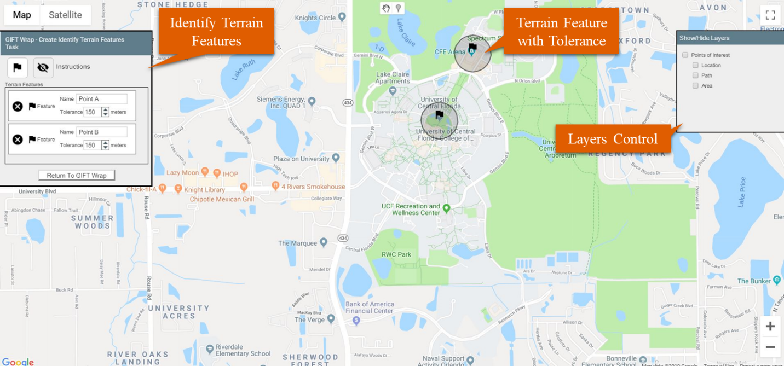
Figure 4. Example Overlay UI for Identify Terrain Features Real-time Assessment
These assessments were intended to be representative of typical training activities on a navigation course in a real-world environment (i.e., the Run phase of skill acquisition). However, instead of the training being delivered by an instructor, the trainee would experience the adaptive training provided by the GIFT Tutor User Interface (TUI) delivering the course via mobile device, such as smartphone (see Figure 5).
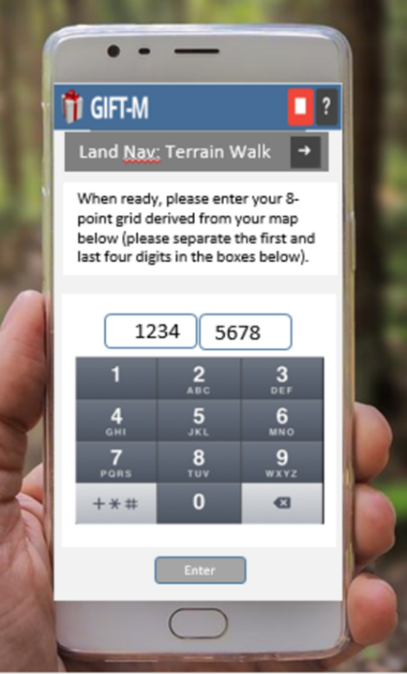
Figure 5. Notional Mock-up of the Mobile TUI
Other GIFT Wrap Enhancements
In an effort to continuously improve the usability of GIFT Wrap, the following features were added to the fourth-generation design:
- Show/hide Instructions – This feature allows GIFT users to view instructions when needed or to reduce the occlusion of the map by the Overlay UI by closing instructions when not needed. This is a particularly useful feature for use with the Google Maps application as it does not support a “movable” overlay, but requires the overlay be docked in place.
- Layers – Considering that users might want to see multiple elements on the same map to visualize the “Terrain Walk” activity, the design was expanded to include controls to show/hide “Layers” which coincide with three common land navigation assessment elements that may be references for multiple condition classes – points, path, areas.
- Points of Interest – This feature allows users to add common map features or elements that may be reused and/or referenced by multiple real-time assessments. Multiple points, paths, and/or areas can be set and later selected for use for the set-up of real-time assessments.
Integration with Google Maps
The GIFT Wrap integration with Google Maps required some workarounds due to incompatibilities. Because Google Maps utilizes a JavaScript application programming interface (API) for web development and GIFT utilizes GWT, software engineers were required to use a third-party tool that allow us to integrate Google Maps with GWT. This API (GWT-MapsV3-Api, 2019) essentially creates a bridge between Google Map's JavaScript API and the GWT framework, thus allowing the GWT developer to implement Google Maps. Once the bridge was in place, the features that could be leveraged for GIFT Wrap were identified by evaluating the relevant land navigation tasks. Based on the real-time assessment to be supported, several tools were selected for implementation. The work then turned to determining how to display the relevant Google Map controls in the GIFT Wrap overlay control panel. The overlay control panel houses the instructions and controls that facilitate the authoring of “learner tasks”. For real-time assessments, the overlay captures the parameters authored for the task and links the parameters of the task with the Google Maps API in order to pass the desired performance data captured during training to GIFT.
The GWT solution provided a proof-of-concept for the approach, though some limitations are evident. For example, Google Maps offers JavaScript API for web, not GWT. The GWT library provided fewer options and an older library which did not allow for use of the most recent Google Maps API features.
Integration with GIFT Baseline
The merge included integrating the technical capabilities previously developed for utilizing LandNavHD and Google Maps for real-time performance assessment. Details on the structure and format of new conditions classes were provided. The GIFT development team provided feedback on expanding Unity applications to support future overlay authoring, so the software was modified to make future expansion easier.
A few challenges were identified. First, a goal for GIFT is to limit the number of conditions classes through re-use across training applications. The applicability and implementation of the condition classes however are influenced by the context and specifics of the domain. Also, for conditions classes referencing points of interest and other map- and position-based elements, the coordinate system(s) in place can impact capacity to re-use without some modification or specification for the selected coordinate system. The newly defined conditions classes are under review to determine if they can be directly re-used.
Versioning and dating issues cause some confusion in merging with the baseline code. Changes in features and functions of variable GIFT versions required repeated modifications to GIFT Wrap code to maintain compatibility. Though the modifications are published by the GIFT development team, it is difficult to know which aspects of the GIFT Wrap are affected until tests were completed or inconsistencies in functioning were observed. This is likely to be an issue for others developing on a separate GIFT code branch and then executing a merge.
Lastly, there were challenges to overcome with implementation and testing GIFT wrap with the mobile version of GIFT and the newly defined condition classes. To deploy GIFT to mobile device, the team used the "Publish Course" feature that generate the Uniform Resource Locator (URL) for the course. From the URL, the course can be accessed. GIFT Cloud allows this feature to be accessed anywhere as long as the user has access to the link. Initially, the version the team developed produced a local URL, which meant that only the local owner’s computer could access the course. The resolution was to launch to Amazon cloud in order to get access the published course URL, just as with the cloud version of GIFT, so that we could test implementation on the mobile phone.
Limitations and challenges
As the GIFT Wrap design has evolved, each iteration of the tool has added features and functionality that incrementally reduced the burden associated with authoring real-time assessments and configuring the delivery of instructional strategies across several training applications. However, there are still many technical challenges to overcome. The following sections describe the current limitations of the tool and some of the future development challenges.
GIFT Wrap Interoperability Limitations and Integration Challenges
As previously described in this paper, GIFT Wrap integration with third-party systems (e.g., Google Maps) remains challenging. While the creation of the Gateway Module and various plugins has allowed for interoperability and reduced development time, there is still a considerable amount of customization required to establish the communication between GIFT Wrap and a training application that is necessary for implementing real-time performance assessments. For example, the third generation of GIFT Wrap was integrated with the LandNavHD training application. The real-time assessments users could author for this training application (e.g., Avoid Area, Locate Navigation Points) required positional data from LandNavHD that were not included in the existing GIFT Unity plugin. Several new event handlers had to be added to the plugin that sent messages to GIFT providing information used for real‐time assessment.
There is also the challenge of integrating GIFT Wrap authoring capabilities with those of the training application. One of the goals for the GIFT Wrap project was to create a “blended authoring environment” that would allow users to author real-time assessments within the context of a training application’s content creation tools via an Overlay UI (Davis et al., 2017). The intent was to merge the GIFT Wrap UI with the content creation tool’s UI in a such a way that users would perceive the tool as one, seamless authoring experience. However, there are two significant challenges to implementing this design. First, some training applications simply lack scenario authoring capabilities. In these cases, workarounds are required to implement the authoring UI as intended. For example, in the case of the LandNavHD Unity game, a top‐down image of the terrain was extracted, and a new layer was created in the GIFT Wrap UI to simulate the functionality of authoring within the training application’s virtual environment. Second, for training applications that do including content creations tools, it’s likely that access to the source code is needed in order to integrate GIFT Wrap functionality. For example, VBS is used by the Army for land navigation training and includes content creation tools (e.g., the Offline Mission Editor (OME)) for creating and editing the scenarios. The GIFT Wrap Overlay UI could potentially be integrated with the VBS OME such that the user could reference elements of the VBS scenario (e.g., waypoints, navigation flags) for real-time assessments (e.g., Locate Navigation Points). However, without access to the proprietary VBS source code, it is impossible to implement this functionality and create a seamless authoring experience for the user.
Authoring Limitations and Challenges
Maximizing usability has been a major focus throughout the development of the GIFT Wrap design. As such, several usability evaluations were conducted (Davis et al., 2018) as GIFT Wrap gradually incorporated DKF Authoring Tool (DAT) functionality and added new authoring capabilities. However, as computer-based tutoring system (CBTS) capabilities continue to advance and the intended use of GIFT Wrap broadens, some of the existing UI features may not be able to accommodate these new use cases. Real-time assessments are becoming more robust, training scenarios are growing in complexity, and the potential applications of CBTS are expanding beyond individuals and small teams to multi-echelon, collective training in new domains. Authoring tools such as GIFT Wrap will need to be modified and, in some cases, completely redesigned to accommodate these changes without compromising the usability of the tool.
Conclusions and Recommendations for FUTURE research
Building on the first three generations of GIFT Wrap, the fourth generation was aimed at extending GIFT’s authoring capabilities for live, land navigation training via integration with Google Maps and GIFT mobile capabilities. With the completion of this integration and new authoring functionality, GIFT Wrap is now capable of supporting a CWR approach to training for the Map Reading and Land Navigation use case.

The most recent GIFT Wrap development efforts have focused primarily on authoring individual, adaptive training for Map Reading and Land Navigation. Many of the existing GIFT Wrap authoring capabilities and corresponding Condition Classes are applicable and/or easily modifiable to accommodate new training applications. Future research should concentrate on extending GIFT Wrap beyond the current use case to other Army elements (e.g., squad, platoon) for collective training and to other training applications across Army domains (e.g., armored, mission command). For example, GIFT Wrap location-based assessments could be slightly modified and used to author real-time assessments for a company team practicing a wedge formation and/or adjusting to the appropriate formation under different circumstances.
Future research should also be done to continuously examine and iteratively improve the GIFT Wrap user experience as use cases continue to be added. For example, the GIFT Wrap UI could be modified to facilitate authoring and visualizing dependencies amongst numerous events including triggering events, team behaviors and/or performance, the impact of instructional strategies, etc. Alternative UI designs should be considered to ensure that the GIFT Wrap tool is flexible and robust enough to accommodate future applications including operational requirements for the Army’s Synthetic Training Environment (STE) capability.
References
Davis, F., Riley, J.M., & & Goldberg, B. (2018). Iterative Development of the GIFT Wrap Authoring Tool. In Proceedings of the Sixth Annual GIFT Users Symposium (GIFTSym6).
Davis, F., Riley, J.M., & & Goldberg, B. (2017). Development of an Integrated, User-Friendly Authoring Tool for Intelligent Tutoring Systems. In Proceedings of the Fifth Annual GIFT Users Symposium (GIFTSym5).
Department of the Army (2007). Map reading and land navigation (FM 3-25.26). Washington, DC.
Goldberg, B., Davis, F., Riley, J. M., & Boyce, M. W. (2017, July). Adaptive training across simulations in support of a crawl-walk-run model of interaction. In International Conference on Augmented Cognition (pp. 116-130). Springer, Cham.
GWT-MapsV3-Api (2019). Retrieved from https://github.com/branflake2267/GWT-Maps-V3-Api
Hoffman, M., Markuck, C., & Goldberg, B. (2016). Using GIFT Wrap to Author Domain Assessment Models with Native Training Applications. In Proceedings of the Fourth Annual GIFT Users Symposium (GIFTSym4).
Shute, V., Ventura, M., Small, M., & Goldberg, B. (2013). Modeling Student Competencies in Video Games Using
Stealth Assessment. In R. Sottilare, A. Graesser, X. Hu & H. Holden (Eds.), Design Recommendations for
Intelligent Tutoring Systems, Volume 1: Learner Modeling (pp. 141-152).
Sottilare, R.A., Brawner, K.W., Goldberg, B.S. & Holden, H.K. (2012). The Generalized Intelligent Framework for Tutoring (GIFT). Concept paper released as part of GIFT software documentation. Orlando, FL: U.S. Army Research Laboratory – Human Research & Engineering Directorate (ARL-HRED). Retrieved from: https://gifttutoring.org/attachments/152/GIFTDescription_0.pdf

