Enhancing GIFT Authoring User Experience through Interaction Design
Robert A. Sottilare, Ross Hoehn, Dar-Wei Chen, and Behrooz Mostafavi
Soar Technology, Inc.

INTRODUCTION

A major consideration in the design of tools that support authoring, instruction, deployment, and evaluation of adaptive instructional systems (AISs) is interaction design. According to Sottilare & Brawner (2018), AISs are artificially-intelligent, computer-based systems that guide learning experiences by tailoring instruction and recommendations based on the goals, needs, and preferences of each individual learner or team in the context of domain learning objectives. AISs include learning technologies that include intelligent tutoring systems (ITSs), intelligent mentors (recommender engines), and intelligent instructional me- dia. According to Preece, Rogers & Sharp (2007, p. 8), interaction design is defined as: “designing interactive products to support the way people communicate and interact in their everyday and working lives”.

This paper specifically examines human interaction with processes enabled by the Generalized Intelligent Framework for Tutoring (GIFT; Sottilare, Brawner, Goldberg & Holden, 2012; Sottilare, Brawner, Sinatra & Johnston, 2017), an open-source architecture for authoring, deploying, autonomously managing, and evaluating adaptive instruction (e.g., ITSs that provide tailored instruction in a domain of knowledge – fundamental systems of the human body, rifle marksmanship or land navigation).

When we consider various aspects of AIS design, interaction design drives us to develop practices that will optimize user interactions during AIS authoring, deployment, instruction, and evaluation processes. We expect to develop recommended practices built upon a model of AIS users that considers:

- AIS user roles (e.g., learners, authors, instructional designers, system maintainers, and researchers)
- Capabilities and limitations of users in various roles
- Contributing factors to quality user experiences
- User feedback about their AIS experiences
- Measures of usability to compare/contrast alternative approaches
As it is for other systems, interaction design for AISs is a multidisciplinary process involving a variety of career fields (e.g., psychologists, computer programmers, and engineers), academic disciplines (e.g., human factors, cognitive psychology, social sciences, and informatics), and design practices (e.g., graphic design, conceptual modeling, engineering design, and product design). Next, we consider the influence of various disciplines (including computer science, psychology, instructional design, cognitive science) in the AIS processes noted above with the goal of enhancing AIS user experiences through improved usability.

AIS USABILITY GOALS

Per Preece, Rogers, & Sharp (2007, p. 20), system usability is defined as “ensuring that interactive products are easy to learn, effective to use, and enjoyable from the user’s perspective”. Preece et al (2007) also associate the following goals/measures with usability that we have applied to GIFT and AISs:

- Goal: highly effective – a measure of how well an AIS is at doing what it was designed to do (e.g., improves knowledge and skills in a particular domain)
- Goal: highly efficient – a measure of how well an AIS is at supporting users in completing tasks or reaching goals
- Goal: high utility – a measure of the extent to which an AIS provides appropriate capabilities to meet user needs or desires
- Goal: easy to learn – a measure of how quickly a user can reach proficiency and use AIS capabilities
- Goal: easy to recall – a measure of how easy it is to remember AIS capabilities once learned
Now that we have identified usability goals associated with the interaction design of AISs, our next step is to apply these goals to the specific processes within GIFT and many AISs to identify interaction design gaps.

APPLYING AIS USABILITY GOALS TO GIFT PROCESSES

In this section, we begin to examine the interaction design of GIFT in terms of GIFT processes and their usability. While we understand that GIFT is a baseline concept or prototype, it does have a level of maturity (Technology Readiness Level 5 or 6 – Mankins, 1995) and a sufficient user base that warrants this examination. We also understand that while GIFT functions may not be present in all AISs, they are representative of AISs in that they have processes and common AIS functional components (i.e., learner model, instructional model, domain model and interface model). A goal of this section is to examine the usability of GIFT authoring tools, adaptive instruction, and evaluation tools through the lens of Nielsen & Molich’s (March 1990) methodology for the heuristic evaluation of user interfaces.

Heuristic evaluation is usually an informal method of evaluating usability where a number of evaluators are presented with an interface design and asked to comment on its ease-of-use as it relates to a set of rules or criteria. In our case, we chose the following heuristics and provide feedback on usability with respect interaction design:

Simple and natural dialogue – GIFT does not provide any mechanism to insure simple and natural dialogue is authored. Feedback though a virtual human (VH) interface and text chat window is primarily at the discretion of the author. However, the VH interface could be greatly improved to engage the learner. Increasing the size of the VH in the dialogue window and the ability to swap out VH personas might be critical for interaction with learners during courses and experiments.

Speak the user’s language/Be consistent – Given GIFT is a multi-disciplinary tool, its taxonomy is expected to be familiar to computer programmers, research psychologists, and instructional designers. This might be a bridge too far. We recommend GIFT adopt the ontology being developed under IEEE Project 2247. The AIS concept modeling subgroup is working with an interdisciplinary group of professionals to develop this ontology to support a common language for AIS authoring, deployment, automated instruction, and evaluation. For more information about the IEEE Project 2247, please visit: http://sites.ieee.org/sa- groups-2247-1/

Minimize user memory load – The authoring process in GIFT has been simplified over the last few years to provide a simple drag and drop interface, and the course objects have labels to identify their functions. This reduced working memory load during the authoring process. However, the optimal order for authoring is not specified and the state of authoring is not displayed for the user. We recommend an authoring dashboard to inform the user about any gaps in the development of a GIFT course or experiment.

Provide feedback – GIFT provides a tool to validate each course and provide textual feedback. We recommend a dashboard with a graphical indicator of authoring tasks and the percentage of the authoring tasks completed. A simplified graphical flow chart would also be useful to the author in tracking progress for the development of courses. GIFT also provides tools to validate and preview courses.

Provide clearly marked exits – In the GIFT course creator (authoring tools), there is a clearly labeled over-head menu with options to navigate from the course creator. Additionally, the upper right corner features a user profile dropdown with a logout command.

Provide shortcuts – No shortcuts are presently available for menu items. However, there are right-click options for edit, delete, and copy for all course objects in the course creator and for whole course in the “take a course” page. We recommend relabeling the “copy” option to read “copy and paste” for consistency.

Good error messages/Prevent errors – The GIFT authoring tools provide a tool to allow the author to preview their course from a specified starting point (e.g., beginning or adaptive courseflow object). Errors result when GIFT attempts to preview the course from a position where input is expected from the learner and was not provided. The preview simply aborts and does not provide an indication of the type of error experienced. An authoring dashboard that indicates common errors would also be useful.

In the next three subsections we examine specific GIFT functions with respect to usability and accessibility: authoring tools, courses, and evaluation tools.

Usability of GIFT Authoring Tools

Based on the large number of publicly available adaptive courses in the GIFT Cloud, the diversity of do- mains that those courses represent, the large number of experiments conducted using GIFT courses, and the drag-and-drop nature of the GIFT Authoring Tools (GAT), we characterize the GAT as having a high degree of usability. It is safe to say that the authoring tools enable users to construct relatively simple knowledge-based products without the need for programming skills, but that their usability with respect to more complex skill-based tasks leveraging external environments (e.g., serious games) are more difficult. Certainly the GIFT authoring tools have been used to construct some very complex tutors for land navigation and rifle marksmanship, but the construction of similar ITS is likely beyond the capabilities of most users.

The tools provide an easy-to-use method to sequence, configure, and modify course objects that represent a variety of content (e.g., media, assessments, surveys, and courseflow objects). A big asset is the survey authoring system which enhances user efficiency by allowing the import of surveys developed in Qualtrix. Another asset is the presence of a validation tool that highlights missing elements in the configuration of course objects. What is not readily apparent is the sequence of identifying learning objectives and linking them to content objects and learner states. Learning objectives, or in GIFT parlance – concepts, must be defined first and then media objects, assessment or survey questions, and courseflow objects can then be configured so they are associated with these concepts.

Three difficult authoring tasks in GIFT involve: 1) association of data sources with learner states, 2) association of content meta-data attributes with learner attributes and instructional phases, and 3) assessment of conditions in external environments.

Association of data sources with learner states – There is a need to define processes to acquire data (e.g., via sensors, surveys, self-reported data) to support classification of current learner states (e.g., engagement, arousal, motivation or domain knowledge) and/or predict future learner states.

Association of content meta-data attributes with learner attributes and instructional phases – There is a need to efficiently tag media and other content to aid content searches in the context of learner conditions and instructional phases (e.g., Merrill’s (1983) Rule Quadrant or Chi & Wylie’s (2014) Interactive-Constructive-Active-Passive (ICAP) model).

Assessment of conditions in external environments – External environments (e.g., simulations such as Virtual Battle Space) are one method to provide interactive learning experiences. There is a need to develop methods to extract external environment conditions so AISs can support learner assessments without the need for computer programming; we recommend a utility to author condition classes automatically based on author specification.

Accessibility of GIFT Authoring Tools

Overall, GIFT and its affiliated authoring tools are extremely accessible in the cloud at https://cloud.gifttu- toring.org. As a cloud-based tool-suite, GIFT provides a scalable architecture that can grow easily with the number of users and the number of courses being developed. Developers can store their courses or experiments in the cloud and provide links to students or participants (Figure 1). Experimental data is stored in the cloud, can be configured for easy analysis using the Event Report Tool (ERT) and exported on demand for further analysis.
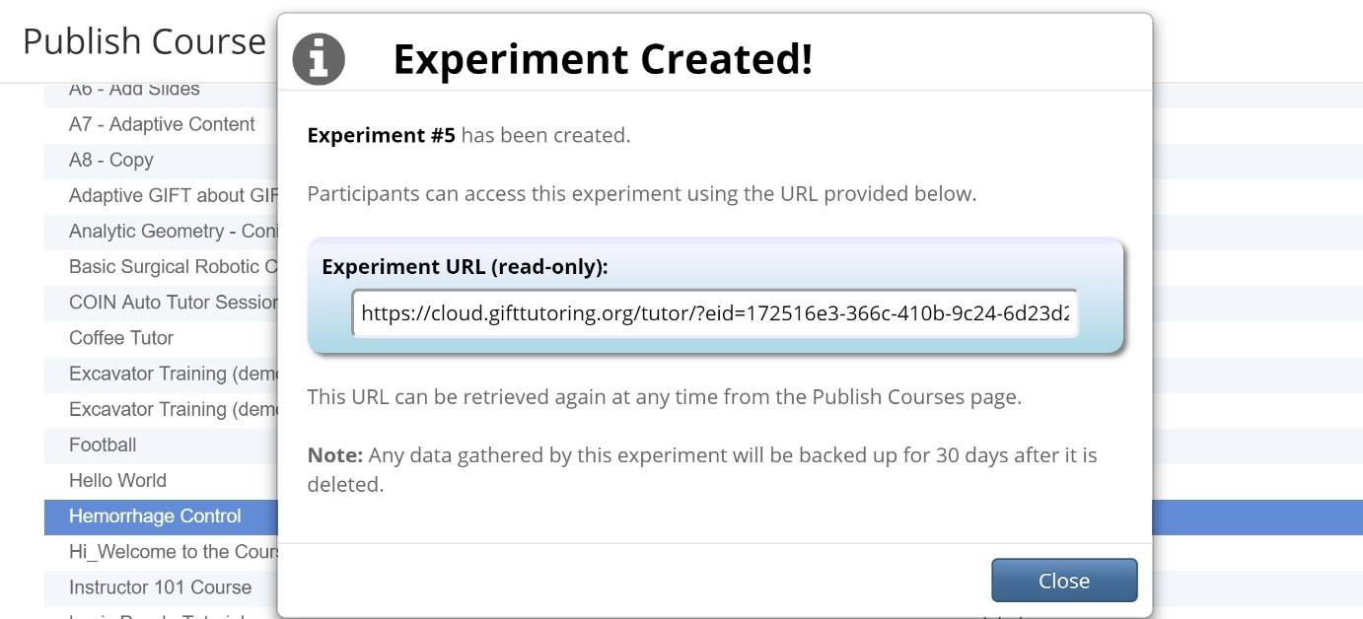
Figure 1. Cloud-based Courses and Experiments

Usability of Adaptive Instructional Courses in GIFT

After logging into the GIFT Cloud-based platform, each learner is introduced to their personalized GIFT Dashboard and a complete tiled list of course materials. They are presented with both title and thumbnail images which are accessible by the individual learner/author. Upon selection of a course, the installation of any necessary plug-ins (e.g., Java applet to run Microsoft PowerPoint) prompt the learner to run and install
required software. This may be distracting, but for the most part can be avoided by using Microsoft PowerPoint slideshows that are converted to images.

GIFT is designed to provide a self-contained platform for AIS material authoring, curating and sharing. To satisfy this requirement, the cloud-based GIFT provides support for Java, UnityGL and embedding of API- based external media. There is great advantage to this capability in that GIFT can be used to point to existing media which satisfies legal access under Fair Use, “a doctrine in the law of the United States that permits limited use of copyrighted material without having to first acquire permission from the copyright holder” (Leval, 1989). Another advantage is that the author of the media retains control and provides updates. The GIFT ITS author is not required to manage the configuration of external media when the tutor simply points to the location of the media.

GIFT facilitates the presentation of instructional material to learners through embedded graphical features, such as slides and videos. Static material is presented in a fashion akin to PowerPoint materials. Individual learning objectives can comprise an entire course, a series of slides or a single slide. Video-based materials can be managed via API-embedding of videos hosted on YouTube. Video controls are native to GIFT, and allow the learner to control their receipt of the video presentation.

Exploiting the GIFT’s use of UnityGL, course materials can be generated in and, thereby, delivered via an interactive synthetic instructor. These instructors present course particulars to the learner by an instructor- avatar reciting scripted materials. Synthetic instructors are also capable of presenting prescript dialogue- based options to the learner via multiple-option input, permitting the learner to direct their own exposure to course materials. Also empowered by UnityGL, a course can contain simulations (e.g. a training simulation for operating an excavator) capable of being entirely contained within GIFT.
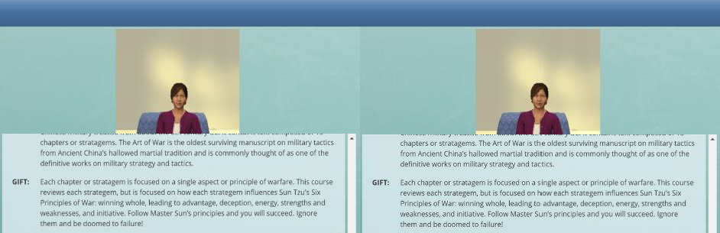

Figure 2. Virtual Human interface in GIFT courses
Left = current interface; Right = recommended more engaging interface

Usability of Evaluation Tools in GIFT

After a course has been developed using the GIFT authoring tools, the course can be published as a experiment or self-contained tutoring platform. Experiments can be hosted on the GIFT Cloud, which facilitates both the collection format and the storage of data. These experiments will appear in the “Publish Courses” tab for management and data retrieval. Selection of an active experiment will provide a link to the course materials to be given to learners, subject metrics (e.g., latest attempt, number of attempts), and a course description. This experiment management environment assists in course sharing, validation, error checking, and metadata tagging.

Within this management screen, collected experimental data can be exported for analysis and publication. Exportation of raw data will generate a copy of a JSON database for all metrics collected while learners were interacting with the course. This database provides extensive information that can be employed in defining and deriving bespoke metrics not yet available in GIFT. A researcher can also have GIFT automatically generate reports containing predefined metrics.

IMPROVING THE INTERACTION DESIGN OF GIFT

In this section, we provide five major recommendations for improving the interaction design of GIFT authoring processes for instruction and experimentation.

Recommendation #1 – Author Dashboard

The usability of the GIFT authoring tools could be greatly improved by the addition of a checklist or author dashboard that highlights prerequisite events in the form of a nodal network (Figure 2).
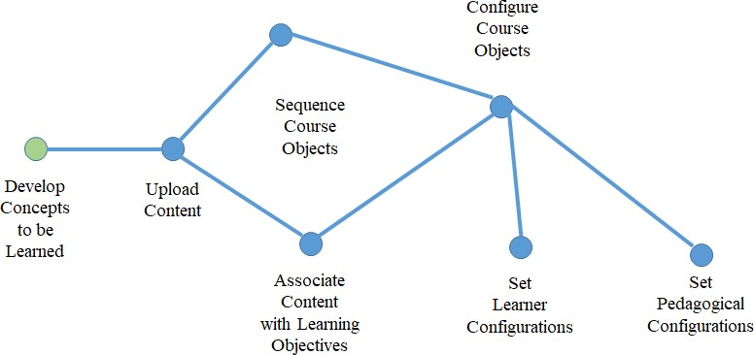

Figure 3. Notional GIFT Author Dashboard Widget: Nodal network depicting authoring tasks and progress

Recommendation #2 – Collaborative Authoring

The usability of the GIFT authoring tools could be greatly improved by expanding the authoring interface for use by multiple authors/instructional designers/content developers.

Recommendation #3 – Researcher Dashboard

The usability of the GIFT ERT used to configure experimental data could be greatly improved through an researcher dashboard that allows researchers to use a WYSIWYG interface to configure data for analysis and reporting.

Recommendation #4 – Condition Class Dashboard

A condition class dashboard (Figure 4) would automate the creation of condition classes to support the acquisition of measures and the assessment of learners with respect to learning objectives.
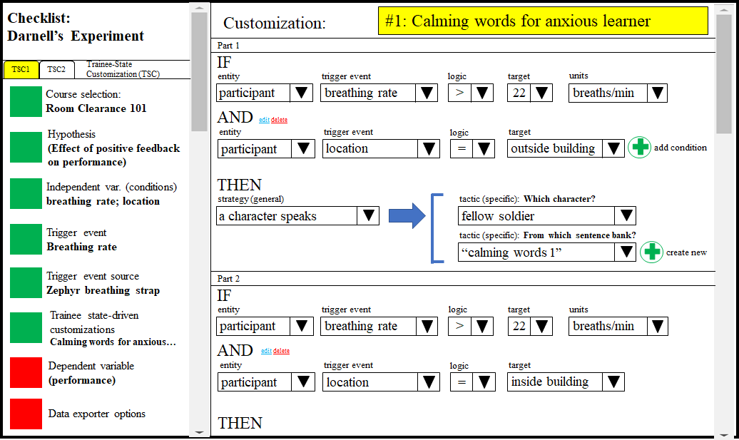

Figure 4. Notional GIFT Condition Class Dashboard:
Provides ability to identify data sources and automate building of condition classes

The communication of data moving between AISs (such as GIFT-based ITSs) and external environments (e.g., serious games, virtual simulations, cases or problem databases) are difficult to facilitate manually, but may lend themselves to a repeatable, automated process. Currently, GIFT provides a mechanism called condition classes, which are specific statements that allow a program to check a condition and execute certain parts of code depending on whether the condition is true or false. Condition classes contain the instructions for how GIFT should respond to data from external environments, including strategies or tactics that occur in the environment (e.g., increasing the number of pedestrians in a city block when the learner’s performance in a surveillance task moves from moderate to high). Today, a computer programmer must manually generate these condition classes. We are suggesting that researchers’ abilities to create training materials and experiments might be enhanced by allowing the author to structure conditions in an intuitive dashboard and then automatically generate the condition classes needed, all without knowledge of program- ming.

This dashboard should implement easily-understood non-programming features (e.g., questions written in prose, if-then statements, drop-down menus of current GIFT-compatible equipment, auto-complete, GUI elements, wizard-style interactions) that a researcher can use to fully input information related to their de- sired condition class. Then, when the researcher has provided all of the relevant information for the condi- tion class, the dashboard should connect to a condition class generator that outputs the JavaScript code for the conditions defined and saves it for other researchers to use in the future. This example solution would expedite training-related research and widen the potential user base of GIFT.

Recommendation #5 – Population Model Dashboard

A population model dashboard would allow authors to import historical data or build population profiles relevant to the knowledge, skills, abilities, attitudes and other characteristics (KSAAOs) of a group or population. Population models are useful in enabling standards, identifying trends, evaluating learner with respect to their peers, and making instructional decisions based on norms. Population models may also be useful in bootstrapping instructional decisions when specific individual learner data is unavailable. We advocate that mechanisms to support/generate instructional decisions be examined within the larger field and context of distributed learning. As such, authoring tools should be data-driven and utilize information from a wider set of domain-independent learning resources. Managing such a wide set of information re- quires constant analysis of instructional and media factors, methods of assessment across a range of environments, and comparisons of required and actual KSAAOs across a variety of domains in order to build population models for structuring pedagogical policies.

Population models are statistical distributions of various learner and team experiences and achievements observed within a population. Populations can be simple or complex, singular or nested within each other. Relating these models within and between domains can facilitate the generation and definition of concepts, assessments, and instructional decisions within the GIFT authoring tools. Population models may include hierarchical cluster distributions of KSAAOs to identify learning gaps and develop recommendations for future experiences, identification of concept dependencies and pre-requisite relationships to support the formation of concept maps for sequencing learning experiences, gap analysis summaries between individual learners and their peer groups at various echelons, and analysis of existing population models with respect to individual and group outcomes to increase the accuracy and precision of the statistical distributions.

CLOSING THOUGHTS

To a great extent, the ease of use for the GIFT authoring tools could be greatly improved and expanded to support the development of more complex tutors. Through the use of visualization (e.g., dashboards) and the development of methods to automate steps in the authoring process, we might realize additional efficiencies. Dashboards, scripts, and, machine learning techniques like genetic algorithms could enhance the authors’ efficiency through guided authoring, automated processes, and improved situational awareness. We highly recommend research to develop tools and methods in support of the authoring process to expand the usability and applicability of GIFT to a larger set of educational and training domains.

REFERENCES

Chi, M. T., & Wylie, R. (2014). The ICAP framework: Linking cognitive engagement to active learning outcomes.
Educational psychologist, 49(4), 219-243.
Leval, P. N. (1989). Toward a fair use standard. Harv. L. Rev., 103, 1105. Mankins, J. C. (1995). Technology readiness levels. White Paper, April, 6, 1995.
Merrill, M. D. (1983). Component display theory. Instructional-design theories and models: An overview of their current status, 1, 282-333.
Nielsen, J., & Molich, R. (1990, March). Heuristic evaluation of user interfaces. In Proceedings of the SIGCHI con- ference on Human factors in computing systems (pp. 249-256). ACM.
Preece, J., Rogers, Y., & Sharp, H. (2007). Interaction design: beyond human-computer interaction. John Wiley & Sons.

Salas, E. (2015). Team training essentials: A research-based guide. London: Routledge.
Sottilare, R. A., Brawner, K. W., Goldberg, B. S., Holden, H. K. (2012). The Generalized Intelligent Framework for Tutoring (GIFT). Concept paper released as part of GIFT software documentation. U.S. Army Research Laboratory— Human Research & Engineering Directorate (ARL-HRED), Orlando, FL, USA.
Sottilare, R., Brawner, K., Sinatra, A., Johnston, J. (2017). An Updated Concept for a Generalized Intelligent Frame- work for Tutoring (GIFT). US Army Research Laboratory, Orlando, FL, USA.
Sottilare, R., Brawner, K. (2018, June). Component Interaction within the Generalized Intelligent Framework for Tutoring (GIFT) as a Model for Adaptive Instructional System Standards. In the Adaptive Instructional System (AIS) Standards Workshop of the 14th International Intelligent Tutoring Systems (ITS) Conference, Montreal, Quebec, Canada.

ABOUT THE AUTHORS

Dr. Robert Sottilare came to SoarTech as the Science Director for Intelligent Training in 2018 after completing a 35- year career in federal service in both the Army and the Navy training science and technology organizations. Most recently, he led adaptive training research at the US Army Research Laboratory where the focus of his research was automated authoring, instructional management, and analysis tools and methods for intelligent tutoring systems (ITSs). He is a co-creator of the Generalized Intelligent Framework for Tutoring (GIFT), an open source, AI-based adaptive instructional architecture used for learning sciences research. GIFT has over 2000 users in 76 countries. He has over 200 technical publications in the learning sciences field (over 1500 citations in the last 5 years). His doctorate is in Modeling & Simulation with a focus in Intelligent Systems from the University of Central Florida.
Dr. Ross D. Hoehn is a research scientist in SoarTech’s Intelligent Training division. He earned is Ph.D. in Theoretical Chemistry from Purdue University in 2014, and continued research in chemical physics, quantum information and artificial intelligence until 2018. His research areas include: adaptive artificial intelligence, generative AI techniques, team learning and training, pedogogy, biological-based agent simulations, swarm mechanics, quantum information science, quantum computing and quantum mechanically-driven biophysical phenomenon. He was an active researcher and manager of the NSF Center for Chemical Innovation: Quantum Information for Quantum Chemistry, a multi-million dollar multi-year research effort centered at Purdue University to utilize quantum computing for quantum mechanical calculations.
Dr. Dar-Wei Chen is a research scientist in SoarTech’s Intelligent Training division where he specializes in applying human factors principles to learning environments. He previously earned a doctoral degree in engineering psychology from the Georgia Institute of Technology and his research led him to be named a finalist for the James D. Foley Scholarship (top Ph.D. students in design and technology at Georgia Tech), recipient of the Larry S. O’Hara Scholarship (top senior Ph.D. student in the College of Sciences), and a recipient of the Georgia Tech Presidential Fellow- ship. His experience with GIFT includes a summer stint with the Learning in Intelligent Tutoring Environments (LITE) Laboratory at the Army Research Laboratory where he used a GIFT-powered simulated shooting range to train cadets on fundamentals of marksmanship.
Dr. Behrooz Mostafavi is a research scientist in SoarTech’s Intelligent Training division. He earned his Ph.D. in Computer Science from North Carolina State University in 2016, with a concentration in intelligent and adaptive instructional systems. He continued research in applying personalized learning techniques to a growing tutoring
framework for discrete mathematics at the undergraduate level during his postdoctoral work at NCSU’s Center for Educational Informatics before joining SoarTech in 2018. His experience with GIFT includes recent in-depth analy- sis and experimental design of mid-level reporting techniques, as well as a study of GIFT and related technologies, techniques, and applications, and written contributions to the Army Research Laboratory Design Recommendations for Intelligent Tutoring Systems series of books.

