The 2019 Instructor’s Guide to GIFT
Anne M. Sinatra
U.S. Army Combat Capabilities Development Command (CCDC) – Soldier Center – Simulation and Training Technology Center (STTC)
Introduction
The Generalized Intelligent Framework for Tutoring (GIFT) is a research project which is continually developing (Sottilare, Brawner, Sinatra, & Johnston, 2017). As a result of this, many of the functionalities within GIFT continue to expand, and some of the interfaces that users interact with are being updated as well. I began writing a series of “Research Psychologist’s Guides” for GIFT in 2014 (Sinatra, 2014; Sinatra, 2016; Sinatra, 2018), and have updated them on a bi-annual basis. The updates to the guide have captured many of the continuing changes that have occurred in GIFT, with the authoring tool and survey authoring systems being dramatically different between the publication times. As a companion piece to these guides, in 2015 the first Instructors’ Guide to GIFT was published (Sinatra, 2015). This guide was written specifically from the perspective of an Instructor who might incorporate GIFT into the class that they were teaching in a number of ways: as an interactive medium for students to learn materials through, as a way to perform assessments, and even as a way to have students create projects for their classes. Since the publication in 2015 there have been many updates to GIFT including GIFT Cloud. The introduction of GIFT Cloud and access through the internet greatly increases the opportunities that an instructor has in using GIFT in their courses. One of the largest barriers to implementing GIFT in the classroom at the time of writing of the original guide was that both the instructor and students would need to install the GIFT soft- ware. Due to the implementation of GIFT Cloud, there is no longer a need to install the software, and the majority of GIFT’s functions can be accessed from a web-enabled computer. This is a very large change and update to GIFT which influences the way that an instructor may use GIFT in a course. Following the format of the “Research Psychologist’s Guide” to GIFT, the current work is an update to the original which also discusses the improvements that have been made to GIFT and new strategies to use with it since the last publication.
This current Instructors’ Guide to GIFT expands upon the original instructor’s guide, and also discusses ways that GIFT Cloud can be implemented in a class. In the current paper, there is an explanation of GIFT’s tools from the perspective of an instructor, and an explanation of how to add previously existing content (e.g., exam questions; test banks; PowerPoint slides) to GIFT. While there are other documents which de- scribe using GIFT’s tools, the current guide specifically discusses how to leverage the tools within GIFT to specifically from the perspective of an instructor who is concerned with grades and content in a formal class. An explanation is provided about how to extract data after a student has interacted with the course. There is additional discussion of the current state of GIFT and improvements that could be made in order to make improve its functionality for instructors.
USING GIFT IN A CLASS
GIFT can be used to create materials that students interact with either in person (in a computer lab) or on their own time. These materials can be used as a primary means of providing information (e.g., in an online course), or as an opportunity to review material on the student’s own time. It is up to the instructor to decide how he or she would like to implement GIFT as part of a class. In the current guide there is discussion of the current functionality that exists, which an instructor can use to decide how to implement GIFT in his or her class. The most straightforward way for an instructor to use GIFT in a class is by creating a linear GIFT course and assigning it to students through a link. The current document discusses the tools that are relevant
for creating a linear GIFT course and publishing it for distribution to students. The remediation and adaptive tutoring functionalities of GIFT may be of interest to advanced users, but are beyond the scope of the current guide. Additional information on how to use these functions can be found on the GIFT YouTube channel.
With GIFT, an instructor can create a number of different “GIFT Courses” which students can interact with. Depending on the author of the courses, each course can be on an individual topic (similar to a module), or they can include multiple learning objectives. If an instructor wishes to create a non-adaptive, linear course which utilizes pre-determined surveys then advanced features such as defining concepts do not need to be utilized within GIFT. However, if the course instructor wishes to implement remediation/adaptive course flow and/or utilize the Question Bank feature of GIFT for randomized questions, he or she will need to identify course concepts within the GIFT authoring tool. These course concepts can then be linked to the the specific items for remediation and the individual questions that are authored in the course specific Ques- tion Bank.
Regardless of the specific way that an instructor plans to implement GIFT within his or her class, they could create materials that support each of the lessons that they are teaching in class and can implement them in the form of GIFT courses. These courses could then either be assigned as optional or required assignments that students can complete on their own time. Additionally, based on the preference of the instructor these materials could either be used for self-regulated review, or as actual graded assignments. In the case of using GIFT for graded assignments, there would be the additional question that the instructor would need to answer – would they be grading for completion of the assignment or actually grading based on the an- swers and activities that the student performs during the GIFT interaction. While both of these options are possible they would require different actions to be taken by the instructor to ensure that the relevant infor- mation is provided in order for them to get the information that they need.
USING GIFT FOR STUDENT ASSIGNMENTS
As mentioned above, GIFT can be used to provide materials and assignments to students in the form of interactions and quizzes that can be used for grades. Additionally, it can be used as a means for presenting materials to students either in class in a computer lab format, or on their own time. One application of GIFT that has been used previously, is to have students interact with GIFT and create their own intelligent tutoring systems (ITSs). Students can be assigned a specific topic that they need to create materials about, and then tasked to create their own ITS with GIFT. Versions of this assignment have been used with students of varying backgrounds and varying education levels including both undergraduate and graduate level. Addi- tionally, if students wish to create their own research projects they can leverage GIFT as a means to do so. This type of assignment may be of particular interest in the field of human computer interaction, or ITS classes. Additionally, since GIFT is an on-going research project, students who complete usability assess- ments of GIFT could submit their outcomes and suggestions for consideration for possible future updates to the overall system.
GIFT FEATURES THAT ARE USEFUL FOR INSTRUCTORS
There are many tools and features of GIFT that are of interest to instructors who wish to implement GIFT within their classes. The most important items are the GIFT Authoring Tool, the new Survey Authoring System, and the “Publish Course” functionality.
GIFT Authoring Tool
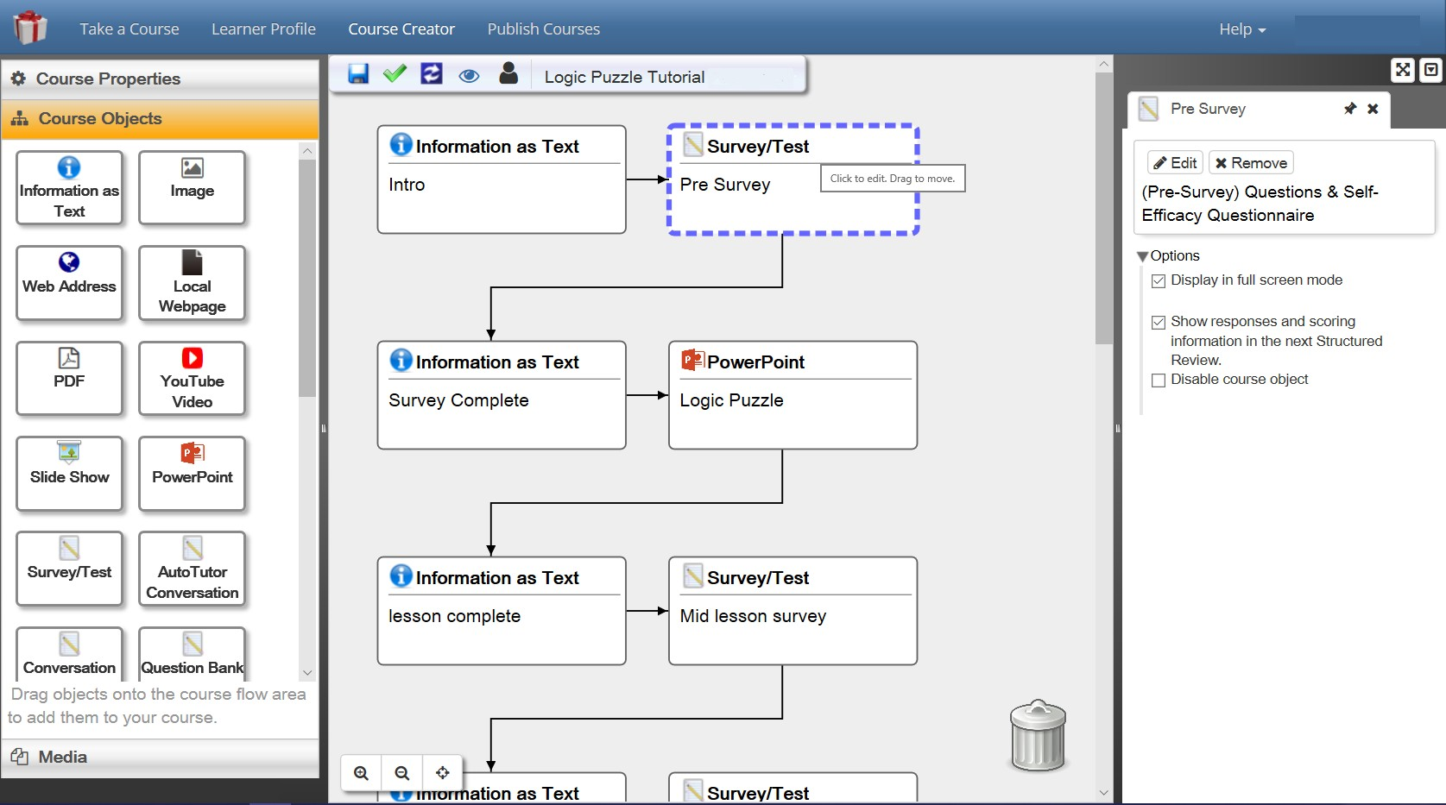
The GIFT Authoring tool has gone through many updates and iterations through the years, and currently features an easy to use drag and drop interface. The left side of tool offers the possible course objects that can be utilized, and the right side of the tool is a course map that displays the order of the objects within the courseflow. Once an object is dragged from the left side of the screen to the main courseflow, it can be authored. The first action is to name the object. This name will be helpful for the instructor so that he or she knows what it is called when they are looking at their overall courseflow. After naming it on the right side of the screen a properties panel will appear that allows for customization of the object. Once an object is authored it can be reordered in the courseflow by clicking on the object with the left mouse button and dragging it to a different place. See Figure 1 for screenshot example of the interface which shows a high- lighted object.
Figure 1. Screenshot of the GIFT Authoring Tool interface with a Survey/Test item highlighted. Course ob- jects are on the left side of the screen, the courseflow is in the center, and the right side of the screen has spe- cific course object properties.
The course objects that are available for use include Information as Text, Image, Web Address, Local Webpage, PDF, YouTube video, Slide Show, PowerPoint, Survey/Test, Conversation, Question Bank, Adaptive Courseflow (this is an advanced feature, and is beyond the scope of the current paper), Structured Review, and external connections with programs such as Virtual Battlespace. In many cases when a media item is selected (e.g., image) the instructor can find it locally on his or her computer and it will be uploaded to their specific GIFT Cloud account.
Course Objects
If the instructor wants to provide information to the students he or she can use “Information as Text” or create an .html file that can be uploaded as a local webpage. If the instructor wants to send students to an external website, the Web Address can be used. It will bring up the webpage with a “Continue” button centered at the bottom of the GIFT interface. This can sometimes lead to potential student error if they click the “Continue” button before reading the webpage, so it can be helpful to include an “Information as Text” object prior to this which explains what they need to do in order to engage with the webpage.
Slide Show Object and PowerPoint Object
Two objects that are of particular note to instructors, and have very different implications for the way that students will interact with the course are “Slide Show” and “PowerPoint”. Both of these course objects are created from a PowerPoint show file (.pps) that the instructor uploads to the course. However, if the Pow- erPoint that already exists consists of only text and static images then the preferred method to use is the “Slide Show” course object. When using the “Slide Show” course object, GIFT will convert the existing PowerPoint show file into images, which students will be prompted to read and advance through. There are a number of different options in order to adjust the interface as the instructor wishes to reduce the chance that a student will accidentally skip through the slides. By using the “Slide Show” course object it allows for students to view the material without needing to download anything to their computers. This creates a fluid online experience.
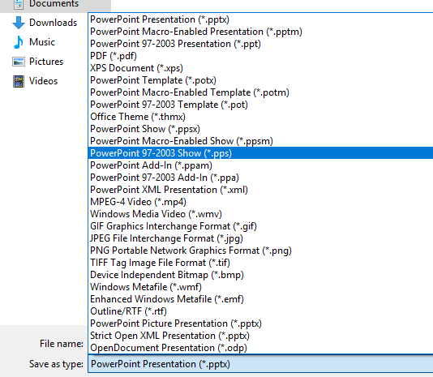
The only instances where one would want to use a “PowerPoint” object file type is if there are macros or videos embedded in the existing original PowerPoint file which are vital to the content. In order to use the “PowerPoint” course object, GIFT will need to connect with an instance of PowerPoint that is on the stu- dent’s computer. This means that in order to run the course the student will need to have a compatible version of PowerPoint installed on their computer. Additionally, it will require the student to download the gateway module that connects GIFT Cloud to their version of PowerPoint on the computer. This can lead to user error, or difficulty with running the specific course. Therefore, it is preferable to use the “Slide Show” object whenever possible. Existing PowerPoints can be saved as .pps files and they will be automat- ically converted to images for the instructor when using the “Slide Show” object. See Figure 2 for how to save your PowerPoint document as PowerPoint Show (.pps), which can then be used by GIFT.
Figure 2. The correct format to save your PowerPoint as for use with GIFT as a Slide Show or PowerPoint object is “PowerPoint 97-2003 Show (*.pps) as highlighted above.
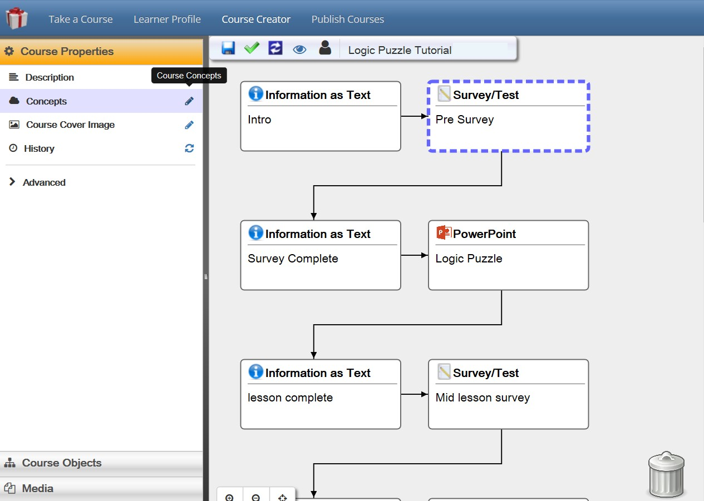
Adding Course Concepts
If an instructor wants to teach more than one concept in a GIFT course, or wants to use Adaptive Courseflow or the Question Bank object, then it is necessary to define Course Concepts in GIFT. To do so on the GIFT Authoring Tool, click on “Course Properties”. Then click on “Concepts”. Figure 3 shows the correct item to click on, and Figure 4 shows what the concept interface looks like. Multiple concepts can be created, and these will later be used to both tag and identify questions in the system that are associated with the proper concepts.
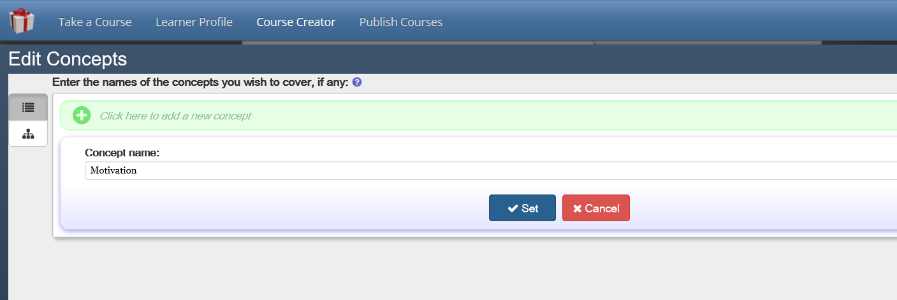
Figure 3. To define Concepts for a GIFT Course click on Course Properties, then the pencil next to Concepts.
Figure 4. Once “Concepts” has been clicked on the interface in this figure will be displayed. For each of your concepts add it by clicking on the green plus button, and then give it a name. By adding these concepts they can later be used in the course.
Question Bank and Survey Course Objects
There is a distinction between using the Question Bank and Survey course objects in GIFT. If an instructor always wants to create a formal quiz or exam in which the same questions display in every instance, then the Survey course object should be used. If questions associ- ated with specific concepts should be selected at random from a bank of questions of vary- ing degrees of difficulty, with different concepts identified, then the Question Bank should be used.
Survey Course Object
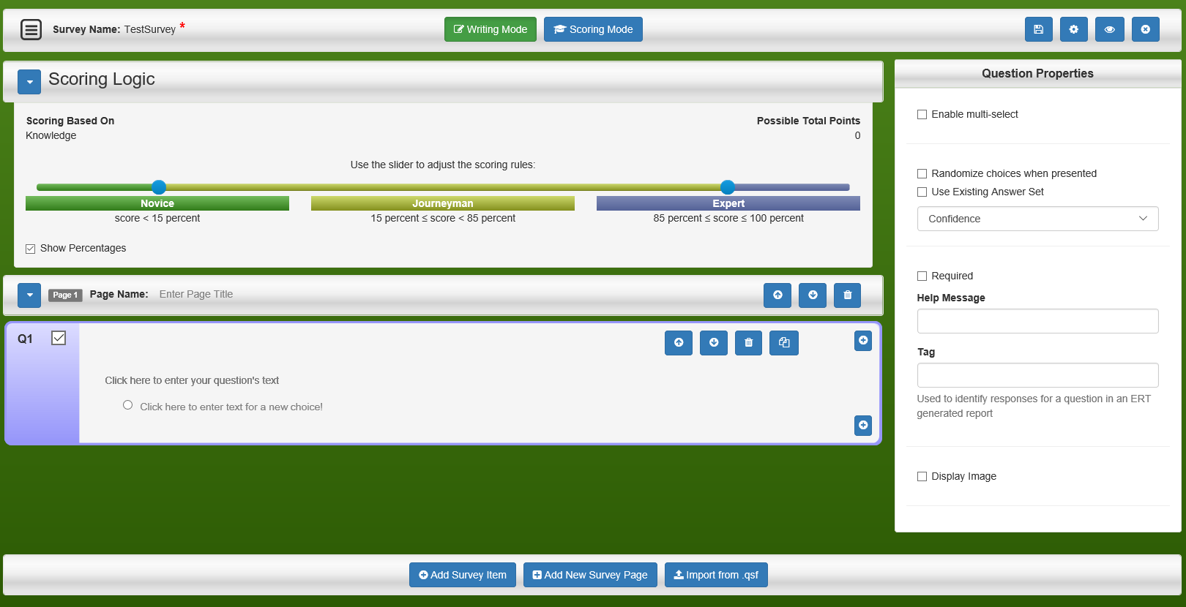
Once a Survey object is selected, an additional selection needs to be made about the type of survey. A different option will be selected if the survey is actionable, non-actionable (the information will not be calculated in real-time for use), or an assessment of learner knowledge. In most cases within a class it would be expected that non-actionable infor- mation would be used when collecting straightforward information from the student such as their name, and the assess learner information selection would be used if the items have correct answers and will be automatically graded by the system. See Figure 5 for a screen- shot of the “Assess Learner Knowledge” option. Note that there is both a writing mode, and a scoring mode that can be selected from the top middle of the interface. It is also im- portant to add a “Tag” to the Question Properties for each question. This will be the name that is available at the top of the column when the data is extracted.
Figure 5. Screenshot of the Survey Interface
Question Bank Object
Each course has its own question bank which is directly linked to concepts that have been defined within the course. Once the Question Bank course object is added, there are two actions that need to be taken. First, questions need to be added to the overall course question bank. Second, the specific questions and concepts that will be assessed in the Question Bank object need to be selected. The number and types of questions will also be identified, as well as the number of correct questions to fall into each type knowledge level. An example of the initial configuration interface for the Question Bank object is in Figure 6. Note that the first step is to click on the “Course Question Bank” item on the top of the screen, which will then take the instructor to the question bank interface.

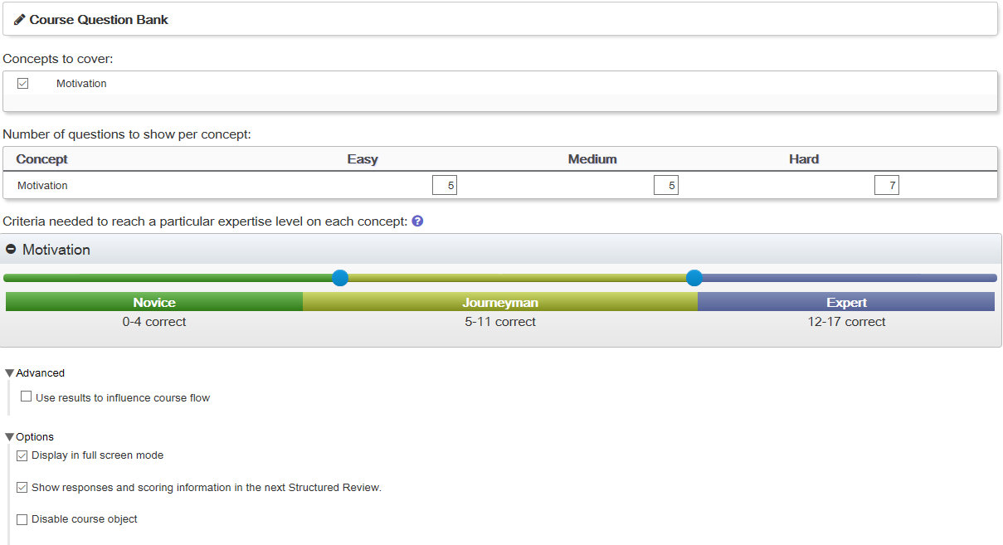
Figure 6. Question Bank object interface. First click on “Course Question Bank” to start adding questions to the overall bank for the course. Next, select the course concepts that will be identified with this specific in- stance of the Question Bank object within your courseflow.
Additionally, the questions that are entered in the main question bank are separate from those that are avail- able in the Survey object discussed previously. The interfaces are very similar, but in order to accurately associate the question bank item with a concept the “Scoring Mode” button needs to be clicked, and the “Question Difficulty” and “Associated Concepts” selected. See Figure 7 for an example.

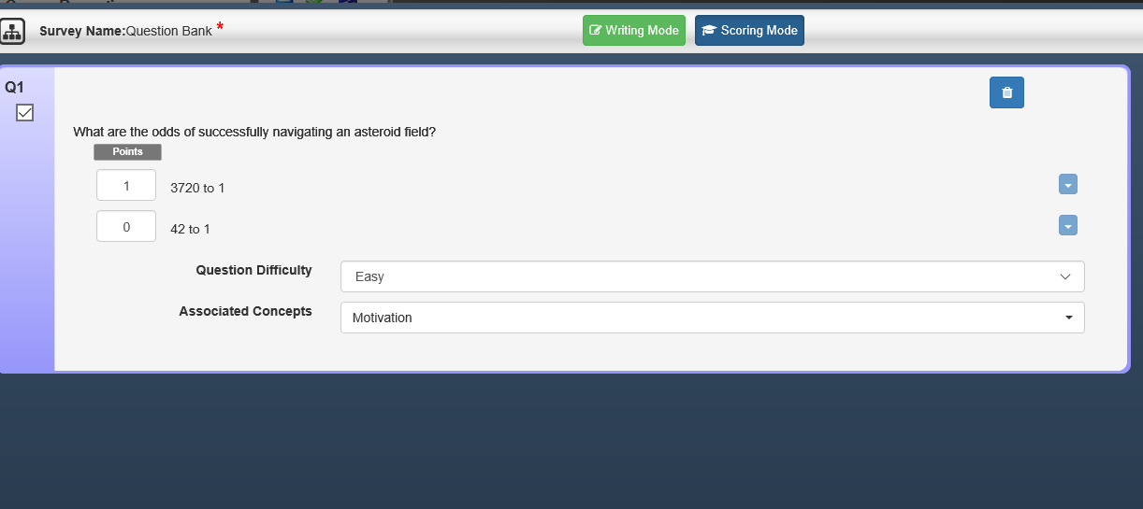

Figure 7. An example of Scoring Mode in a Question Bank. It is important to set the Question Difficulty, and select associated concepts.
Publish Course and Data Extraction

There are two methods that can be used to provide a course to an individual student. These include either exporting the course for import to the student’s GIFT Cloud account, or pub- lishing the course. The recommended method to use at the current time is the “Publish Course” functionality. At current time, while importing the course would result in linking
the scores to an individual student’s account, there is no way for the instructor to automati- cally retrieve the information that students enter in the system. This information is stored on the main instance of GIFT running on the Cloud and would require the GIFT team to provide it. The current solution is to use the “Publish Course” option. Publish Course takes the existing version of a course and provides a URL for it so that students can access it from the link. Since this method is not directly linked to a student’s GIFT account, in order to use the output for grade purposes, a demographic question will need to be added to the course that asks that student to enter his or her name or a relevant student ID number.
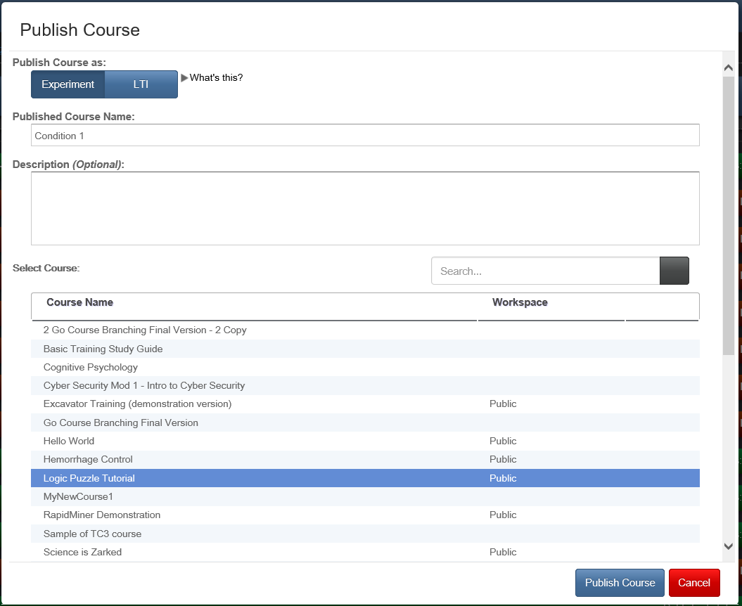
Once “Publish Course” is selected it brings up an interface that has red or green bars for already existing published courses. To publish a new course, click the “Publish Course” button on the top left side of the screen. While the overall terminology has been updated, this functionality was originally used for experiments, and the correct selection to make on the pop up screen is “Publish Course as Experiment”. You then type in a name for the course, and then select a course from the displayed list. See Figure 8 for a screenshot of this interface.
Figure 8. The Publish Course interface.
A URL will be provided that links students to that specific instance of the course so that they can interact with it. It is important to note that this publish functionality is copying the selected GIFT course at that moment in time. If any updates or edits are made to the origi- nal course file, a new published version of the course and URL must be produced in order for students to be able to interact with the new version.
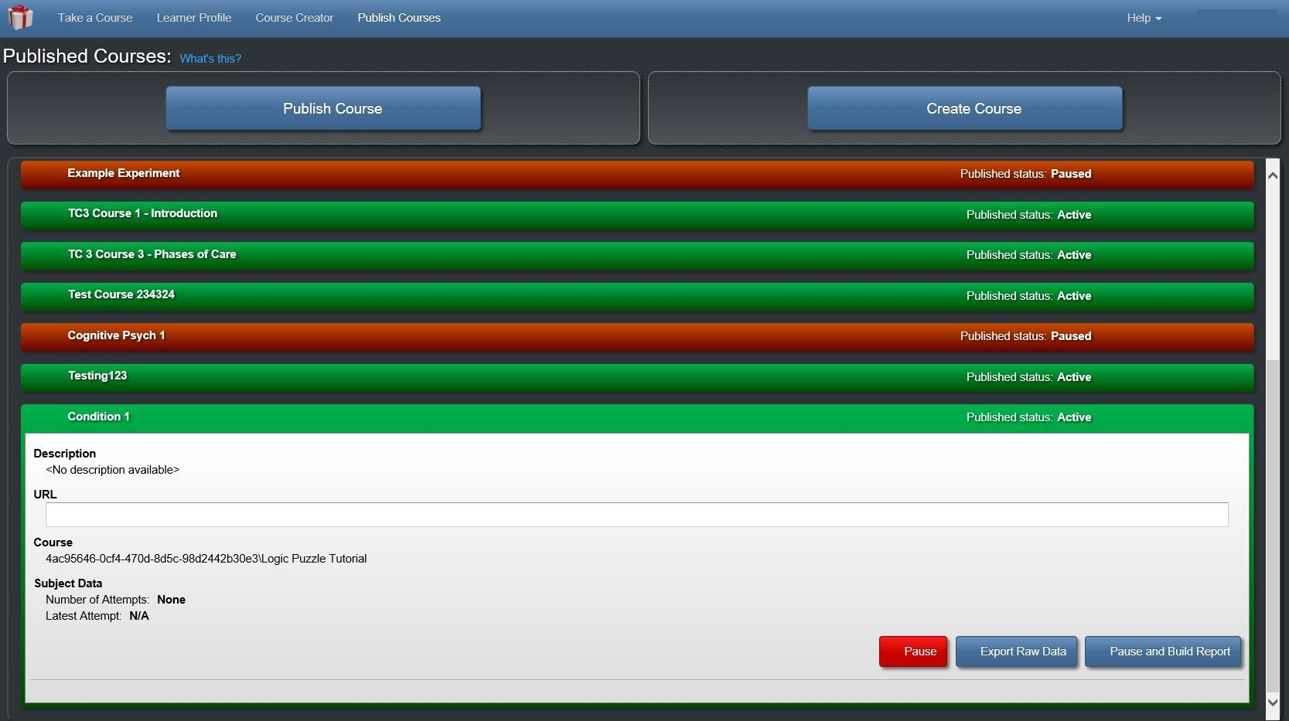
After students have interacted with a course, an instructor can use the red and green course name interface in “Publish Courses” in order to extract data. Again, this design is primarily based on functionality that is of use in running experiments. See Figures 9 and 10 for an example of these interfaces. However, in order for the data to be extracted, for the space instance, “Pause and Build Report” must be clicked and the data downloaded. To extract survey data, be sure to check the box that says “Survey Responses”, and in order to have each participant on one line in the exported document click “Merge each participant’s events into a single row”. This will then build a file that then needs to be saved to the com- puter. It will be a .CSV file which can then be opened in Excel. If the cells are merged, each student’s inputs will be listed on a single row. The tags that were added in the survey authoring process will be available at the top of each column. This is why it is very important to add tags to each of the questions, as otherwise numbers that do not provide information about the question’s content will be visible. Any needed post processing can then be completed on the file in Excel or the desired program.
Figure 9. Published course interface

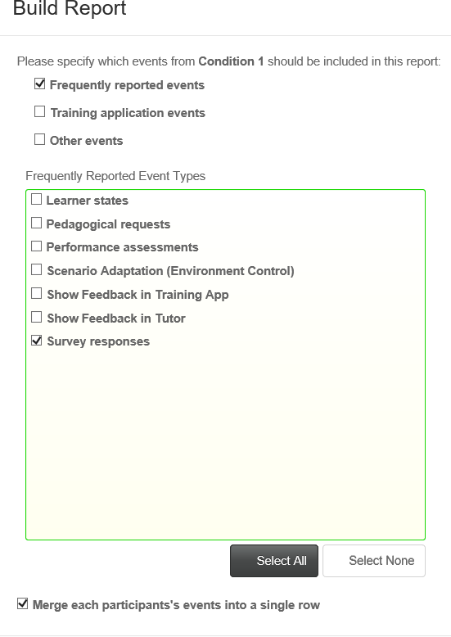
Figure 10. Build a report interface for extracting student data.
SUGGESTIONS FOR IMPROVEMENTS TO GIFT
As identified earlier in the paper, while there are many features of GIFT that are highly relevant for use by instructors, there are still some challenges to implementing it in an actual class.
Gradebook
Currently there is no easy way to have student learning outcomes populated into a course gradebook. It would be helpful to implement features into GIFT which provide this functionality for instructors. The most effective way to currently use GIFT for an assignment at current time would be as a pass/fail participation grade in which the instructor can do a quick export of the data and see that the student participated. If quiz scores need to be examined or calculated then it is more work for the instructor, and the format that is exported may not easily import into existing gradebooks that the instructor may be utilizing in other sys- tems.
Student and Teacher Roles
In the current GIFT Cloud setup there is no way for the course creator (or even the student) to export data from the course that they have created while they are logged into their own account. It would be beneficial to have a function that is similar to that of the “Publish Courses” option which would allow for the specific data that has been generated from the course to be viewed from the main GIFT interface while logged in. One way to help implement this would be by creating teacher and student roles in the course. Then the course creator can indicate the GIFT account of the teacher, which could have access to the shared course’s logs. GIFT has begun moving in this direction through the ability to share courses. The next step would be distinguishing between students and teachers and updating interfaces to reflect the role that the individual has in the system. This of course is not a straightforward task and will need to take into consideration special cases such as graduate students who are both instructors and students. Additionally, the implementation of a learning management system and potential gradebook features in GIFT could assist in addressing some of the current challenges to implementing GIFT in a class.
Test Bank Import
Many educational textbook publishers provide text banks which include questions that are associated with each chapter of content. These test banks often come in formats that are compatible with Learning Man- agement Systems such as Blackboard and Webcourses. If these testbanks could be imported into GIFT it would save instructors time in inputting quiz questions. Additionally, there needs to be further clarity on the ability to reuse questions between surveys and question banks in GIFT in order to reduce mistakes when adding questions to the system. There is currently a Qualtrics import functionality for questions in GIFT. It may be helpful to identify textbook test bank formats and create import functions for them as well.
CONCLUSIONS AND RECOMMENDATIONS FOR FUTURE RESEARCH
While GIFT is a very powerful tool and can be of great use to instructors, there are still some challenges and function gaps that exist in GIFT. The implementation of a learner management system and persistent learner record store with the ability to provide information to instructors would be very helpful. Additionally, streamlining and clarifying the difference between Question Banks and Surveys would be helpful for instructors. The current guide provides recommendations, and instructions on how to implement GIFT in a class. The current optimal configuration to use would be to create a GIFT course which utilizes the Slide Show course object and distributing it to students using the “Publish Course” option. In order to facilitate using GIFT in a course, a few small feature updates could be made (e.g., gradebook/grade export, student/teacher roles) which would greatly improve the ease of use. GIFT is very useful in the current state, but with additional improvements it will become an even more powerful tool for instructors to utilize.
REFERENCES
Sinatra, A. M. (2014). The research psychologist’s guide to GIFT. In Proceedings of the 2nd Annual GIFT Users Symposium (pp. 85-92).
Sinatra, A. M. (2015, August). The Instructor’s Guide to GIFT: Recommendations for using GIFT In and Out of the Classroom. In Generalized Intelligent Framework for Tutoring (GIFT) Users Symposium (GIFTSym3) (p. 149).
Sinatra, A. M. (2016). The Updated Research Psychologist’s Guide to GIFT. In Generalized Intelligent Framework for Tutoring (GIFT) Users Symposium (GIFTSym4) (p. 135).
Sinatra, A. M. (2018, May). The 2018 Research Psychologist’s Guide to GIFT. In Proceedings of the Sixth Annual GIFT Users Symposium (Vol. 6, p. 259). US Army Research Laboratory.
Sottilare, R. A., Brawner, K. W., Sinatra, A. M., & Johnston, J. H. (2017). An updated concept for a Generalized Intelligent Framework for Tutoring (GIFT). GIFTtutoring. org.
ABOUT THE AUTHOR
Dr. Anne M. Sinatra is part of the adaptive training research team within CCDC Soldier Center STTC’s Learning in Intelligent Tutoring Environments (LITE) Lab, and works on the Generalized Intelligent Framework for Tutoring (GIFT) project. Her background is in Human Factors and Cognitive Psychology.
ACKNOWLEDGEMENTS
The research described herein has been sponsored by the U.S Army Combat Capabilities Development Command – Soldier Center – Simulation and Training Technology Center. The statements and opinions expressed in this article do not necessarily reflect the position or the policy of the United States Govern- ment, and no official endorsement should be inferred.

